Dreaming Across Borders and Disciplines: Novel Network Metrics in the Context of an Organizational Analysis of a Sun-Belt Advocacy Group

A thesis presented by

Luis Fernando Esteva Sueiro

to

The Committee on Special Concentrations in partial fulfillment of the requirements for a degree in Group Dynamics with honors of Bachelor of Arts Harvard College

March 2024

## Acknowledgments

This thesis is the culmination not just of many hours, but many people beyond myself, without whom it would not have been possible to complete. First and foremost, my deepest gratitude goes to my advisor, Professor John Carroll for helping me navigate my first experience in fieldwork, working with me through tight deadlines, and inspiring an interest in the realm of organizational analysis in my sophomore year of college. I am also incredibly thankful to Professor Amir Ajorlou who, despite my lack of experience in math and coding, has coached me through the field of network science and helped me understand the potential of its many applications.

Thank you to the leadership and members of DREAM, the organization I studied in this thesis, for welcoming me into their team and sharing so much of their history, passion, and city with me for the sake of furthering the study of voluntary associations. Mil gracias por todo.

Lastly, I could not have navigated this thesis without the help of several of my friends, who helped me fill many gaps in my knowledge and refine this thesis into its final form: Alexandra Kassinis, Carlie McGrath, Conrad Hock, Cooper Bosch, Evgeni Kayryakov, Gred Braho, Luis Renteria, and Prazul Wokhlu. Thank you.

## Abstract

This thesis is a three-part analysis of a single organization called DREAM which conducted advocacy for and provided low-cost legal services to undocumented immigrants in a large sun-belt city. The first part of the analysis is based on qualitative observations and interviews collected over the course of one month of fieldwork. The fieldwork uncovered that DREAM was underreliant on formal structures, but was highly adaptive to changing circumstances due to its leadership’s diverse expertise and the strong familial culture which resulted in high levels of trust, particularly amongst its leadership, who were literally family.

The second part of the thesis is a social network analysis of 4 different networks constructed of the organization: a structural network, a communication network, a help network, and a trust network. The SNA highlighted the discrepancies between DREAM’s formal assignments and the levels of activity actually taking place, as well as a division in the organization between its members working in the office and its members in the field engaging with the community.

The third and final portion of the thesis is a proposal of new metrics for social network analysis that combine various network statistics in order to quantify the characteristics of organizations. Their construction is presented and explained, and they are then calculated using the networks of DREAM and connected to the analysis in the previous sections. Most of the metrics’ results aligned with the organizational and social network analyses as expected, providing useful quantitative representations of DREAM’s characteristics and showing promise as tools to be further developed in the study of groups.

## Table of Contents

Acknowledgments 2

Abstract 3

Table of Contents 4

**Chapter I: Overview** 6

Introduction 6

Literature Review 7

Review of Organizational Analysis 7

Review of Network Theory 9

Examples of Social Network Analysis (SNA) 10

**Chapter II: Fieldwork** 12

Description of Fieldwork 12

Organization History 12

Structural Design Lens Analysis 14

Political Lens Description and Analysis 20

Cultural Lens Description and Analysis 22

Synthesis of the Three Lenses 25

Summary of Organizational Analysis 26

**Chapter III: Social Network Analysis** 28

Introduction to Network Analysis 28

Methods of Network Analysis 28

Structural Network 29

Communication Network 32

Help Network 34

Trust Network 39

Pearson’s Correlation Coefficients 42

Summary of Network Analysis 44

**Chapter IV: Novel Metrics for Social Network Analysis** 46

Preliminaries and Definitions 46

Connectivity Scores (*CSz*) 47

Mutual Trust Score (*MT*) 48

Bridge Vulnerability Score (*BV*) 49

Inter-Community Density (*ICδz*) 50

Inter-Community Leader Density (*ICδzLeaders*) 51

Mutual Help Score (*MH*) 52

Informal Connectivity Score (*CSinformal*): 54

Formal-Informal Discrepancy Score (*FID*): 54

Relational Coordination Score (*RC*) 55

Applications to DREAM 55

Structural Network Scores 56

Communication Network Scores 57

Help Network Scores 59

Trust Network Scores 60

Combined Metrics and General Inferences 61

**Chapter V: Conclusion** 63

Limitations 63

Potential Future Work 65

Final Summary 65

**Appendix** 68

Appendix A: DREAM Network Survey 68

Appendix B: DREAM Novel Metric Scores 71

Appendix C: Degree (*δ*) vs Mean Closeness Centrality (*CC*) Correlation 72

Appendix D: *MH* *LCδmodifier* Values 73

# Chapter I: Overview

## Introduction

It is a fundamental function of human nature to organize into groups. These groups’ dynamics can vary in nature and objective, ranging from which children get picked for soccer teams first during recess, to how platoons of soldiers balance loyalty to each other and loyalty to their mission, to voluntary associations collaborating to further their mutual interests. Voluntary associations are organizations created by people who voluntarily come together to pool social capital and facilitate collective action toward a common goal which can be political, religious, recreational, social, and more. In modern democracy, they are one of the fundamental instruments of civil society, and critical for the proper representation of groups with disproportionately less financial backing or media presence, such as undocumented immigrants. Voluntary associations that advocate for undocumented immigrants in the United States are few and far between, but crucial to ensuring the well-being of a sector of society that contributes significant tax revenue, labor in critical industries, and diverse communities to the United States.[1]

In preparation for this thesis, I spent a month shadowing a voluntary association that conducted advocacy and provided low-cost legal services for undocumented immigrants in a large city in the Sun Belt of the United States and made observations framed by the Three Lenses for Organizational Analysis (structural, political, and cultural).[2] The organization provided defense and resources for the empowerment and advocacy of migrants, and so I will refer to it as DREAM throughout the rest of this thesis for the sake of anonymity.

However, in order to better understand and make judgments upon the efficacy of voluntary associations such as DREAM, or any organization for that matter, I argue that their study must include a quantitative component. The field of social network analysis (SNA) provides an intuitive framework with which to measure various characteristics of groups. Therefore, I created network models of DREAM as part of my fieldwork, and, in conjunction with the Three Lenses framework, they will be one of my primary methods of analysis for this thesis.

## Literature Review

Before delving into my research, I will provide some background on the fundamental concepts that I build upon. They are primarily divided into exploring different methods of organizational analysis and SNA.

## Review of Organizational Analysis

The Three Lenses for Organizational Analysis is a framework compiled by researchers at the MIT Sloan and Simmons Graduate Schools of Management in order to serve as a simplified model for managers to understand complex dynamics and identify interventions if necessary.[3] The three lenses are the strategic/structural lens, the political lens, and the cultural lens.

The structural design lens encapsulates how an organization is formally designed, how hierarchies are structured on paper, and where individuals’ explicit responsibilities lie. When looking through the structural lens it is as if we are imagining the organization was built from the ground up by a managerial architect, with detailed plans and specifications followed to a tee. Examples of manifestations of the structural design lens include designated teams, hierarchies, and reporting structures in an organization.

The political lens, on the other hand, encompasses the more informal side of organizations, how things actually get done, and who holds power where especially when the distribution of power diverges from official positions. The political lens is not concerned with titles, but more with the unspoken undercurrents that occur in organizations and who commands them. Some examples of the political lens in action include entrenched employees resisting mandated changes, lobbying for the allocation of discretionary funds, and the formation of informal alliances between individuals or departments in order to achieve mutual goals.

Lastly, the cultural lens focuses on understanding the shared values, beliefs, and practices unique to the organization which can affect behavior in the organization. Group cultures can be highly influential in how group members feel belonging, are motivated, navigate conflict, and in extreme cases, even abandon the group. Some examples where the cultural lens can be applied in organizations are with rituals, like group-specific holidays, stories and myths about the history of the group, and language specific to the organization.[4]

Another framework that I apply in my thesis is that of Relational Coordination (RC), which I discuss in Chapter 4. RC is a theory of organizational behavior that puts forward that collaborative work is most effective when coordinated through “shared goals, shared knowledge, and mutual respect, and supported by frequent, timely, accurate, and problem-solving communication.”[5] In recent years, the potential for RC to become more integrated with the field of SNA has begun to be explored, particularly in terms of visualizations.[6]

## Review of Network Theory

I assume an understanding of some concepts of network theory for this thesis, particularly for chapter 4. However, I will briefly summarize some crucial concepts here. Networks, sometimes referred to as graphs, are composed of nodes connected by edges.[7] In some instances, edges can be assigned properties like weight and direction. The weight of an edge represents a magnitude of the relationship more complex than the otherwise binary version. These are referred to as weighted and unweighted edges, respectively, and can be used to describe networks at large when these edges are present. The other property I mention, direction, modifies edges by giving them a source node and a target node, representing relationships that are not definitionally mutual. Both edges and networks can be referred to as directed or undirected based on the presence of this kind of edge.

Another important concept to understand in network theory is centrality. Centralities are measurements of different kinds of importances in networks. The simplest one, degree centrality, simply counts how many edges connect a node to other nodes, and assigns this number as the node’s degree centrality. There are various other methods of centrality which are calculated in different ways and highlight different traits of nodes in networks. For example, eigenvector centrality can serve as a representation of the influence of a specific node’s neighbors,[8] and betweenness centrality can serve as a representation of a node’s role in connecting other nodes across the network. The last concept I will describe is density, a value found by considering all possible edges between nodes in a network and then calculating how many edges actually exist in the network. This serves as an easy, yet simplistic metric of connectivity in graphs.

## Examples of Social Network Analysis (SNA)

One example of network analysis applied to voluntary associations was a paper that created affiliation networks between individuals and organizations as well as between individuals based on organizational affiliation with the objective of better understanding recruitment in social movements.[9] The study did not focus on a single organization but it applied network statistics to voluntary associations in an interesting way, such as by using uncommon measures of centrality. They evaluated the prominence centrality of individuals, a centrality measure that values connections to influential nodes in a similar way to eigenvector centrality, in order to determine how those nodes might be recruited into other voluntary organizations.

Another study constructed discussion networks that measured who members of student organizations discussed important matters with and used them to compare general discussion and political discussion.[10] It detected several features of the student organizations such as the tendency towards homophily in discussion and variation between the connectivity of general and political discussion networks, with connectivity tending to be lower in the latter.

There are many more unique ways in which network theory can be applied to organizational analysis and the study of voluntary organizations in particular. In fact, network theory is so diverse a field that new configurations of collected data and network statistics present opportunities for new perspectives on how the future of social network analysis might progress. In this thesis, I draw inspiration from various approaches to SNA to further the field and deepen its connection to more qualitative organizational analysis.

# Chapter II: Fieldwork

## Description of Fieldwork

From mid-July until mid-August 2023, I lived in the city where DREAM operates and went into the office Monday-Friday, from 9:00 am to 4:00 pm, their typical operating hours. While in the office, I would shadow different members of the organization as they went about their daily tasks, and in some instances aided with simple tasks. Sometimes, instead of staying in the office, I would join the advocacy team in their fieldwork, knocking on doors, tabling, or meeting with community members. Additionally, I interviewed every DREAM member[11] at least once with questions about their experience in DREAM, their connections to other members, and their perceptions of organization culture (See Appendix — for the interview template I used). Lastly, I attended three events outside of their scheduled operating hours, a tabling session at a local community center, an informational community meeting, and a college application workshop.

## Organization History

DREAM is fundamentally a family business. It was founded in 2007 as a student advocacy organization by a mother and her three children who moved to the US and ended up overstaying their visas. The mother had a history of political advocacy in Mexico and was even present at the infamous Tlatelolco Square Massacre of student protestors in Mexico City in 1968. In my interview with her youngest son, he described how she passed down her political disposition to the rest of the family by bringing them to protests with her and encouraging involvement in advocacy organizations in their youth. Before the founding of DREAM, the family was heavily involved in immigrant and student advocacy, primarily through an organization of mostly Central American immigrants. However, when the family traveled to their state capitol to testify in favor of pro-dreamer[12] legislation, they found themselves feeling “more at home with [organizations working with Dreamers].”

DREAM was founded in their family living room with the mission to advocate for the rights of immigrant families and students, with a specific focus on undocumented immigrants. Their main activities were the organization of marches, protests, and rallies, as well as policy advocacy. However, the organization did not come into its current form until 2012, after the issuance of Deferred Action for Childhood Arrivals (DACA). In August of 2012, just over a month after the creation of DACA, DREAM leased an office space and began providing low-cost legal assistance to Dreamers filing for DACA status. The initial DACA application period was described to me as one of the most intense periods in the history of DREAM, with all 10 employees working 12+ hour days, 6 days a week, for over 1 month in order to process the massive influx of applicants. DACA renewals continue to be one of the most common requests that they process to this day.

The last major transition of DREAM’s history was the 2021 office expansion and logo rebrand. As a result of the pandemic, DREAM was able to nearly double its office space by expanding into what used to be a neighboring Guatemalan church. This expansion allowed for the creation of a large lobby that doubles as an event space, more room for paralegals and file cabinets, and even a dedicated playroom for the children of employees. DREAM also redesigned its logo to align more closely with the story of its founding and one of the main themes in its real name.

## Structural Design Lens Analysis

DREAM is divided into three primary teams: community advocacy, legal, and education, each spearheaded by one of the three siblings (see Figure 1). The oldest is in charge of the legal team, the second oldest, who is also the executive director, works closest with the community advocacy team, and the youngest is the sole member of the education team. The mother serves as the CFO. An old friend from their time organizing with the Central American organization is the co-director of the community advocacy team along with the executive director.[13] The legal team is also partially managed by the oldest sibling’s spouse, who *Figure 1: Formal Structure of DREAM including team assignments*

serves as the office manager, and has the largest number of employees of all three teams. The office manager serves as a second-in-command to the legal director, helping her manage employees and cases.

When I was visiting DREAM there were 6 employees on the legal team: the director, the office manager, the archivist, a paralegal, the receptionist, and an intern. The first four had been with DREAM for the longest and were connected through family, while the latter two had only recently found the organization through an online search and joined three months and one week prior to my arrival, respectively. Their primary work was the provision of low-cost legal services including DACA renewals, deportation cases, and permanent resident applications.

The majority of visitors and callers were looking for legal services. The most common service that would be solicited which they did not provide was assistance with asylum cases. The legal team was also responsible for manning the front desk as well as the phone and were therefore typically the first to interact with any community member who sought out DREAM. The layout of the office was such that the legal team was in a large open room right behind the reception which allowed them all to speak to each other from their desks, except for the director and office manager who had adjacent offices just down the hall.

The community advocacy team did not have any employees apart from the executive director and co-director and instead relied on volunteers for the majority of its work. In my month with DREAM, I met four volunteers and an unpaid intern working with the community advocacy team. Two of the volunteers were connected with DREAM because of their parents’ friendship with the executive director, and the other two volunteers as well as the unpaid intern were connected to DREAM through relations it had built with other organizations in the city. None had worked with DREAM for longer than two months, although the community advocacy team maintained a mailing list including former volunteers that numbered around 9,000 members. Although they had a lot of volunteers on the mailing list, few were consistently engaged.

DREAM was therefore constantly training new volunteers but turnover was not a concern because the vast majority of these volunteers were not full-time community organizers. This did, however, create the issue of having to train volunteers almost every time an event was organized, which appeared to be done in an ad hoc manner for every event. I shadowed two volunteers at a phone bank spreading information about an upcoming event and they were only given a general overview of the purpose of the phone bank and what information to take down before being left to their own devices. After a bit of initial hesitation, the volunteers ended up creating their own phone bank script which they shared with each other. Experienced volunteers are able to make do without explicit guidelines, but in order to avoid confusion when new volunteers are brought in, DREAM could create and store written guidelines and best practices, such as phone bank script templates, to be shared at the beginning of trainings.

Their primary responsibilities can vary depending on the needs of the community but include organizing protests and community events, speaking to the media and elected officials, attending political events representing DREAM, doorknocking campaigns, and even investigating issues facing the community. For example, the primary focus of the community advocacy team when I was with them was spreading awareness about how to submit a complaint to the Federal Trade Commission (FTC) regarding a pyramid scheme that targeted Spanish-speaking immigrants. Another active project of the community advocacy team was a partnership with the county government to run surveys in a community where a road renovation project was being planned. Surveys in the form of doorknocking and phone banking were strategies heavily prioritized by the co-director, and he stated in an interview that “before any project that asks us for the community’s opinion we run a survey… [because] we don’t represent people, people represent people.”[14]

The executive director and community advocacy co-director’s offices were adjacent to each other and in the back of the office. This is crucial because they worked very closely together, with the executive director more focused on engagement with the media, with local politicians, and in giving speeches. Whereas the co-director of advocacy was responsible for volunteer management, community events, and running smaller and more “on the ground” initiatives. However, it is worth noting there was an exit between their offices and the legal department’s area which allowed them to exit without passing the legal department, and they typically did so. Sometimes this would lead to uncertainty as to whether the advocacy team was still present in the office and reduced the amount of interaction between them and the legal team.

Lastly, the education team consisted solely of the youngest sibling. It was the most recently established team and existed primarily due to their passion for the project. The team’s main responsibilities are to assist undocumented students in applying to university and acquiring financial aid as well as to train high school counselors on how they can better assist their own undocumented students with the college application and financial aid processes. The director also will frequently hold one-on-one meetings with parents and students to discuss the college process. The director’s office is adjacent to those of the community advocacy team and is the same distance from the legal team.

DREAM did not have a clear, explicit, and widely available mission statement and founding document. There were several key phrases or sayings that could be seen all over the office (see cultural lens section), but I was unable to find a concretely defined mission statement. In fact, when I asked the education director, one of the founding members, about the existence of a mission statement or folder of founding documents, the education director was unsure as to its existence and recommended I ask the executive director. When I asked the executive director, they said that they had them somewhere, but never shared them with me. Should DREAM ever look to expand its operations or transition its leadership to newer members, explicitly defined and easily accessible foundational documents would be crucial for the transition.

It is also important to note that DREAM’s assigned responsibilities, especially for directors, are not strictly bounded. DREAM heavily depends on flexibility between teams, high task autonomy, and the advocacy team’s ability to take on almost any issue presented to them, at any time. In the event of the absence of one or multiple directors for any reason, other directors are able to step in and provide effective leadership and support. For example, when the legal director was absent for the first week of my time with DREAM, the education director played an active role in assigning tasks and answering questions. He worked particularly closely with more inexperienced members of the legal team, providing direction and support.

Despite funding from grants, donors, and legal fees, DREAM does not enjoy an abundance of resources and therefore can find itself understaffed in the face of exceptional circumstances such as a new influx of DACA applications or a significant event in the world of immigration which requires rapid mobilization, such as the 2022 San Antonio Migrant Tragedy.

For some peripheral employees, this lower funding proved to be a barrier to their continued participation. Near the end of my time with DREAM the paralegal had to leave due to an inability to make ends meet on her DREAM salary. The legal intern reported in an interview that low pay was the primary reason she would not return to work at DREAM full-time. In order to fill the gap of the paralegal’s exit, the secretary was moved to her position since she had been exposed to legal work for several months and a new secretary was brought in to handle the front desk.

In many situations like this one, experienced team members would shift from their formal responsibilities to fill gaps of leadership or manpower. At the higher leadership level, the legal and education director’s experience from DREAM’s early days as an advocacy organization allows them to fill in and run tables at community events or assist with the organization of rallies and protests. Conversely, due to the influx of DACA applications at its inception, all of DREAM’s team members at the time learned how to process the legal documents they worked with.

For example, before the creation of the education team, its director was a key member of the legal team, and I witnessed the director helping the intern and new secretary with questions on DACA renewal forms many times. In fact, for the first week I was with DREAM, both the executive director and the legal director were on a personal trip, so I witnessed how the education director and advocacy co-director stepped up to assume more responsibilities in the legal and advocacy teams respectively. Even once the other directors had returned, I accompanied the education director to a community event where they tabled to spread awareness for DREAM, a task that would typically fall under the purview of the advocacy team. Furthermore, the event took place on a Saturday morning and the director brought their family with them. This was a prime example of the shared commitment, shared vision, and drive to support the organization which was especially strong amongst the directors.

However, this flexibility applied to more than just the directors who had years of experience in each other’s realms. In an interview I did with the archivist, he reported that in the event of a large DREAM event like a march or protest, the entire office would close up and the legal and education teams would support the efforts of the advocacy team. Vice versa, during massive surges of legal applications, members of the education and advocacy teams would move to support the legal team, as they did during the initial enactment of DACA.

One particular issue I encountered with DREAM’s flexible assignments was that there was no assigned position to create graphics for events. As a result of this, I witnessed a delay in the creation of a poster for a college application forum because the person who was the most acquainted with the creative software was the executive director, who was also typically the most busy. Therefore, it took significantly longer than it could have to begin advertising the event.

## Political Lens Description and Analysis

The primary stakeholders in DREAM ran along the team divisions outlined in the structural lens. Each director, who had been involved in DREAM since its inception, had their own vision for what DREAM should be and prioritize. There was significant overlap in these visions, however, I also, understandably, detected slight biases towards each director’s own team. Fortunately, the autonomy enjoyed by each director generally allowed them to pursue their own projects in their own fields. The executive director spent much of his time engaging with external stakeholders in the city such as leaders of other voluntary associations, local representatives, and media, the legal director was focused on her legal team, and the education director would run his own initiatives on college applications and financial aid.

I did not witness any real conflict or significant disagreement, but I got the impression that, as siblings, they resolved all disagreements discreetly and amicably. I hypothesize that none of them would ever push for their own initiative over that of their siblings to the point of true conflict for the sake of preserving familial ties. That said, I also picked up on potential undertones of seniority based on age and position for the legal director and executive director respectively.

As discussed in the structural lens description, the dichotomy of responsibilities between the executive director and advocacy co-director is well established, however, there is also an informal delegation of tasks. In an interview, the executive director explained to me that, when dealing with external parties ranging from politicians to community members, he and the co-director assume the roles of “good-cop bad-cop” when necessary. When they need to press a local representative for action or submit a statement to the media, the executive director takes the more diplomatic approach to preserve DREAM’s relationships as an organization.

On the other hand, the co-director, who still acts as a formal representative of DREAM, will be more blunt in his statements in an attempt to pressure other parties into results or to send a strong message. In interviews with the executive director and advocacy co-director recounting stories where they used this approach, it seemed to be a very effective tactic to protect DREAM’s reputation and relationships while also maintaining the capability to pressure politicians, media outlets, and even individual community members when necessary. One example they gave was a situation after a natural disaster where the city was, in their eyes, failing to protect low-income immigrants’ rights as tenants. While the advocacy director gathered testimony from community members and gave scathing interviews to local media, the executive director acted as a mediator with local officials and was able to steer their response to mounting pressure from the public.

The overreliance on experienced members of the organization flexibly moving out of their official position to support other teams ad hoc was also slightly problematic as it meant their experience did not become institutionalized. For example, the education director developed his own analogy to explain the various paths to citizenship to community members inquiring about the process. I witnessed how it simplified the processes and facilitated understanding, but also witnessed that it was only passed down to other members of the organization if he happened to be called over to help them with that specific issue. Pooling collective experience into a standardized training or book of resources could simplify the training of new paralegals as well as advocacy volunteers.

Another informal dynamic that had not yet become reflected in the formal structure was that the CFO (the mother) was being transitioned into retirement and was no longer heavily involved in the finances of the organization. In fact, in the month I shadowed DREAM, I did not see the CFO in the office once. The executive and legal directors appeared to be acting as the primary financial decision-makers. This led to a situation where the education director had to negotiate with the two of them in order to secure funds for the aforementioned college application event. I did not witness the discussion over the funds since it was handled as a private matter between siblings, but it did seem to reflect the slight marginalization of the education team.

## Cultural Lens Description and Analysis

In order to understand DREAM it is incredibly important to understand its culture, as it permeates almost all aspects of its operations and is tangibly present every day in the office and beyond. The word that came up the most frequently in interviews and casual conversations with DREAM members was “family.” DREAM’s inception in the family living room of its four primary founders certainly set it on the trajectory of being a family-led organization, however, the sentiment has stuck around and been continually reinforced by leadership.

First and foremost, the vast majority of individuals involved with DREAM are either family of the four founders or family friends. Of the fifteen people who I interviewed about their work with DREAM, only five were not connected by family or friends. Of these five, two were volunteers and two were temporary interns, with only one full-time employee having found DREAM via an online job search. Of the core connected by friends and family, there was an intimate personal connection between all of them. Old inside jokes, clever nicknames, and thoughtful birthday presents were commonplace in the office between those who had known each other the longest and there were many old photos and shared memorabilia plastered on all the walls of the office.

However, this sense of familial connection was not restricted to those who had known each other for years. Newer members of the organization were eagerly welcomed and treated almost like younger cousins. I observed one interaction where the executive director took a break from his work to spend time by the front desk with the new secretary and intern. Instead of being intimidated by his presence, they were opening up about personal matters and the executive director listened to them, provided thoughtful advice, and cracked jokes to ease tension whenever they sensed it.

Although DREAM did not have a formal mission statement clearly advertised or posted anywhere in its office, the following sayings were either posted around the office or were common sayings of the leadership, both of which most of the members were aware of:

1. The number one rule of DREAM is to always be ready for anything
2. *Mi lucha es tu lucha* (My fight is your fight)
3. We don’t represent people, people represent people
4. We aim to politicize people

DREAM’s number one rule was the first thing the new employees reported being told about the organization before they began their work there. In fact, it was the first thing that I was told when I reached out about working with them. Particularly on the community advocacy team, members were always prepared to respond to any crisis or opportunity at a moment’s notice. In my interview with the executive director, he mentioned situations such as when he and the co-director drove several hours to another major city within an hour of receiving notice that they were needed there. Furthermore, there was a mutual understanding amongst all members that they may have to leave the office to attend a rally, table at a community event on a weekend, or stay late to process DACA applications depending on situational needs.

This was balanced with a fairly relaxed work culture during low-intensity periods, which reduced the likelihood of employee burnout during short bursts of high-intensity operations. The relaxed work culture was characterized by employees rolling in 30 minutes to an hour after the office opening, leaving up to 30 minutes early when they completed all major tasks for the day, and periods of socializing, both one-on-one and office-wide, throughout the day. Another aspect of the work culture that I observed improved team morale was the treatment of DACA’s anniversary as an unofficial company holiday. The executive and education director bought lunch for the entire office and over the hour-long lunch break shared stories of the early days of DACA and DREAM’s legal team. Not only did the family-style lunch improve morale, but I particularly noticed how the stories of DACA’s impact and DREAM’s history grounded both the older and the newer members in the history and mission of the organization. This sense of connection to community service was reported in several interviews to be one of the reasons why most employees were willing to stick with DREAM despite relatively low pay.

The next three sayings: “*mi lucha es tu lucha”*, “we don’t represent people, people represent people”, and “we aim to politicize people,” all describe DREAM’s relationship with the community as opposed to internal practices. All three phrases were heavily driven by the advocacy co-director’s approach to community organizing. Although the advocacy director didn’t coin all three, his position as the sole leader consistently engaging directly with the community (due to the executive director’s higher-level focus) meant that he set the tone of DREAM’s approach. In my interviews with him and in volunteer trainings I observed, he emphasized that he and his volunteers should not aim to impose events, positions, and advocacy on community members, but should instead empower them to organize their own events and inform their own ideas with DREAM’s support.

Using the example of spreading awareness about the circulating pyramid scheme, he did not organize his own events on the topic but encouraged affected individuals to coordinate with all the other victims and meet in a public space or private home, where he would come and speak about the issue. This was very successful as it relied on existing community networks organizing with each other as opposed to DREAM seeking to recruit individuals it had not been previously connected to. This process of teaching individuals to organize themselves as well as supporting them in learning how and why to organize is what DREAM referred to as its process of “politicization.” Furthermore, politicization creates a culture of individual initiative which reduces the burden on DREAM to organize events, and it instead can simply show up to support politicized individuals.

It is also worth noting that DREAM operated exclusively in English and Spanish despite technically being an organization for all immigrants, in a city with several other immigrant communities that do not speak Spanish. This has never materialized in any conflict or confrontation as far as I know, but was a surprising discovery given the multiculturality of the city which DREAM inhabited.

## Synthesis of the Three Lenses

In addition to their significant individual effects, elements of the three lenses operate interactively to enable the dynamics present in DREAM. The establishment of shared responsibilities and vision between senior members, extensive and diversified experience, as well as the familial culture that establishes mutual trust combine to give DREAM an impressive amount of flexibility despite its relatively low resources. This flexibility gives DREAM a startup-like dynamic in the sense that it is able to pivot and fully commit team members and resources towards projects out of their typical realm of responsibility while also maintaining a low risk of conflict thanks to its high levels of mutual trust. This is one of DREAM’s greatest strengths.

The omnipresence of family in the organization can also have neutral and detrimental effects, though. When coworkers are simultaneously mothers and sons, brothers and sisters, and in-laws it can make it difficult to separate the professional from the personal. The flexibility afforded to the CFO is undoubtedly influenced by the impulse of a child to take care of their mother as she moves into retirement. Although the executive and legal directors were able to step in and assume responsibility of finances thanks to DREAM’s flexibility, a lack of defined responsibility can lead to confusion as to where true decision-making resides. Especially when unassigned responsibilities, such as finances and graphic design, get passed on to the most central leader, this can lead to an excess of small basic tasks that could be easily delegated to other positions taking over the mental space of the most important decision-maker in the organization.

## Summary of Organizational Analysis

DREAM’s founding by a family with an extensive background in advocacy created an organizational culture deeply committed to the success of the organization, its peers, and its cause supporting immigrants. The experience of and mutual trust between its veteran members gives it the ability to adapt roles and responsibilities allows for rapid response to rapid changes in needs and crises. It has a deep reach into the community thanks to the community advocacy co-director’s philosophy of politicization and empowerment of community members. Finally, its familial atmosphere fosters a strong sense of belonging and commitment among team members, even those who are not connected by blood or have not been involved in the organization for long.

However, finances place a strain on organization members and can restrict the opportunities of certain members who are less tied to the organization than the core family members. The abundance of informal roles and the absence of an explicit mission statement or founding document create the potential to lead to organizational ambiguities or misunderstandings. Heavy reliance on the founding family and its close associates for leadership, direction, and the core network of mutual trust would likely limit the scalability of DREAM, should that become a goal in the future, and make it vulnerable to the exit of key players. Lastly, DREAM’s training processes in both the legal and advocacy teams could benefit from collective input and subsequent standardization. The primary operation in English and Spanish appears to imply that DREAM is limiting itself to a subcommunity of the immigrant population. This is not necessarily an issue, but it represents a targeted approach that could limit its future expansion, should that become a goal.

# Chapter III: Social Network Analysis

## Introduction to Network Analysis

In addition to spending a month shadowing, interviewing, and observing DREAM and its members, I created four network models of the organization. The first is the structural network, a representation of the official hierarchy of the organization and what positions were formally assigned to work with each other. The structural network is unweighted and undirected. The next three were communication, help, and trust networks, which I constructed based on the results of a survey I ran near the end of my time with DREAM. All three networks are directed and weighted. The communication network represents the frequency with which DREAM members communicate with each other, the help network represents the frequency with which they ask one another for help with a DREAM-related task, and the trust network represents the level to which they trust other members.

## Methods of Network Analysis

The survey that gathered the data for the other three networks (see Appendix A for the full thing) was sent to all DREAM employees, interns, and participating volunteers in the last week of my month with the organization. I defined my network boundary as the employees, interns, and the 4 volunteers I encountered over the course of the month. It asked them to rate their levels of communication, frequency of asking for help, and trust in all other members on a scale of 0 to 3. In the communication section of the survey, a rating of 0 was defined as communicating with someone a few times a month or less, including never, 1 was defined as about once a week, 2 was defined as once a day or a few days a week, and 3 as at least several times a day. In the help section of the survey, 0 was defined as never asking this person for help, 1 as sometimes asking for help, 2 as often asking for help, and 3 as being the first person they ask for help. Finally, in the trust section 0 was defined as not trusting this person, 1 as a neutral sentiment of neither trust nor distrust, 2 as moderate trust in this person, and 3 as completely trusting the person.

Unfortunately, the executive director, CFO, and new secretary did not respond to the survey and the data for the latter three networks is incomplete. In order to still work with the data I chose to set the weights of their outgoing edges of those three members to be equal to the incoming edges of each member in the communication and trust networks. I made this decision because communication and trust are both reciprocal actions.[15] I left the help network as is since it is unreasonable to approximate who they ask for help based on who asks them for help. All of the network statistics were calculated in Python using the NetworkX package whereas the network visualizations and Louvain community detection[16] were done in Gephi.

## Structural Network

Since there was no single document outlining the hierarchies of the organization, I constructed the structural network (see Figure 2 )[17] based on the official team assignments of each member, as well as who they were assigned to report updates to. *Figure 2: DREAM Structural Network*

The layout I created was confirmed to be an accurate representation of the formal structure of DREAM by its leadership.

The structural network is connected, unweighted, and undirected. I used two community detection methods on the network: spectral clustering[18] and the Louvain method. The two algorithms disagreed slightly on where to cut the network, with spectral clustering including the executive director in the advocacy community (red), and Louvain including them in the legal/education community (blue), which is understandable considering that, although he works more closely with community advocacy, he is the link to the rest of the organization and has more connections to legal employees than to advocacy volunteers. Despite the confusion on the placement of the executive director, both algorithms performed fairly well in detecting the divide between the legal and advocacy teams. It also makes sense that the education director was considered part of the legal community since he was responsible for 2 of the legal team members.

For its 15 nodes, there are only 22 edges in the network, giving it a fairly low density of 0.21 (see Table 1 for network statistics). This rightfully represents the fact that the structural network is not well connected, potentially as a result of it not even being well defined by DREAM, and emblematic of DREAM’s general lack of reliance on its formal structures. There is also a low average clustering coefficient (0.286) in the structural network which *Table 1: Structural Network Statistics*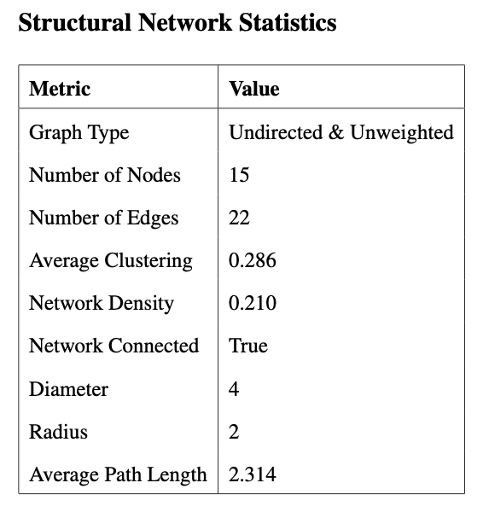

is a further indication of the lack of connectivity in the network.

Furthermore, the centrality distributions of the structural network (see Table 2) add the interesting perspective that, although the network is indeed low in connectivity, it is not equally so across all members. All of the centrality distributions are heavily skewed right. The distribution of betweenness centrality in the network (see 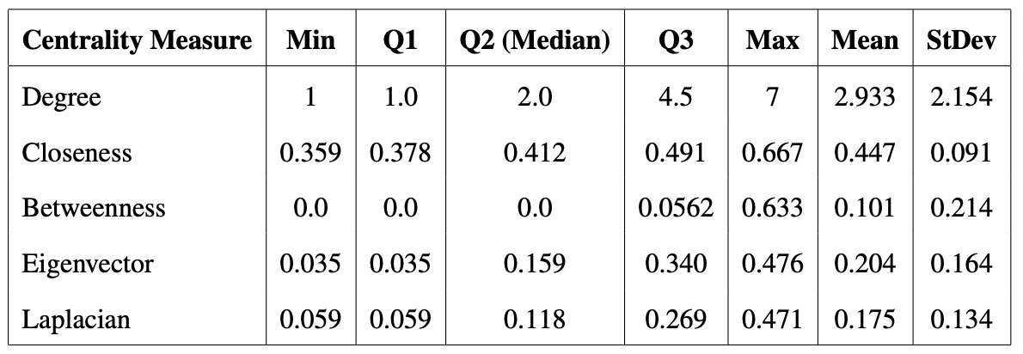

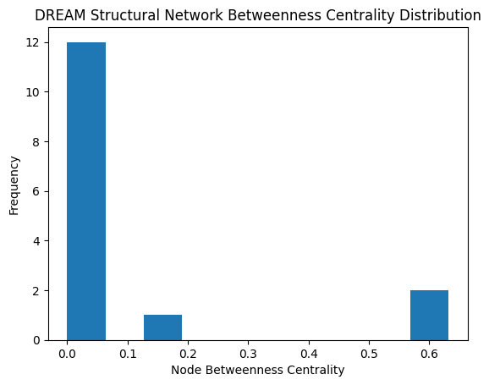 *Table 2: Structural Network Centrality Distributions Summary* Figure 2) is a particularly good example. It shows that of 15, 12 members of DREAM are not assigned to a position that lies on the shortest path connecting two other members. Just two leaders, the executive director and advocacy co-director are officially responsible for connecting the vast majority of the network.

This distribution shape is reflected in the other centrality measures I calculated, with *Figure 2: Structural Betweenness Centrality Distribution* thesame primary leaders having the highest centralities and most other members having very low centralities. DREAM’s lack of emphasis on its formal structure is reflected very strongly, making its network vulnerable to disconnection should key bridges be compromised and suffering from generally low connectivity.

## Communication Network

The communication network is directed and weighted, however, due to the nature of communication as a mutual endeavor, I averaged out the reported weights of communication between members in order to create undirected weighted edges which approximate the true amount of communication occurring between members. The resulting graph is undirected & weighted with 15 nodes and 52 edges, giving it a density of 0.495, more than double than that of the structural network (see Figure 3 for the network visualization[19] and Table 3 for full network statistics). This *Figure 3: DREAM Communication Network*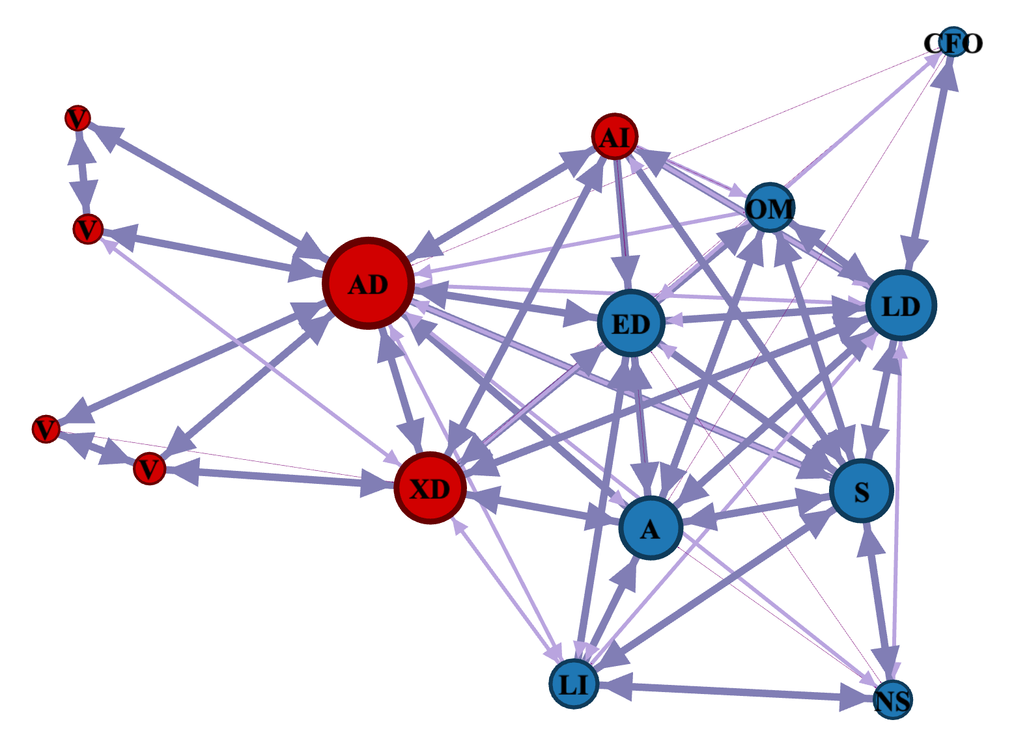

demonstrates that although DREAM did not rely on a formal structure, the organization was still very healthy, with a great deal of communication between its members beyond their formal positions.

Spectral clustering and Louvain agreed on where to cut the network, with the detected communities following formal assignments with the exceptions of the advocacy intern and the executive director who were both placed in the legal team community (blue). Despite confusion on the placement of the executive director, both algorithms performed fairly well in detecting the divide between the legal and advocacy teams.

It also makes sense that the education director was considered part of the legal community since he was responsible for 2 of the legal team members.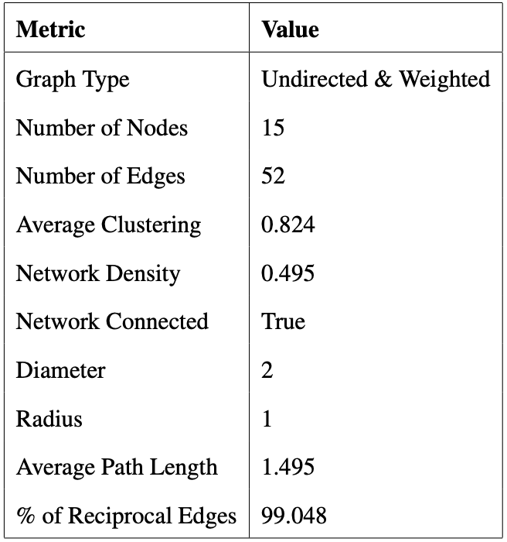

It is also interesting to note that the average clustering coefficient of the network (0.824) was far higher than that of the structural network (0.286), yet another piece of evidence that DREAM was fairly well-connected in terms of communication. Furthermore, the diameter and

*Table 3: Communication Network Statistics* radius of the communication network are each half of their counterparts in the structural network, reflecting the fact that information can spread much faster than the formal hierarchy would allow on its own.

The centrality distributions (see Table 4) of the communication network are generally less right-skewed than those of the structural network, except for betweenness centrality, which is even more right-skewed. The maximum betweenness centrality of the communication graph is 0.349 compared to the 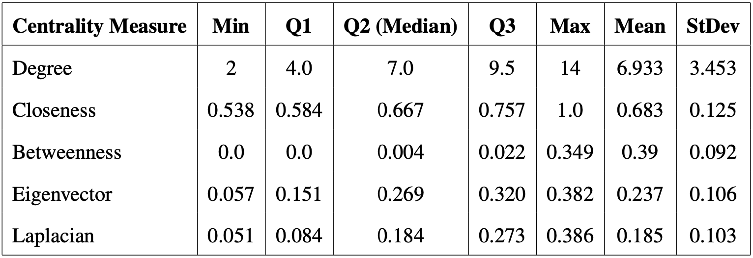

*Table 4: Communication Network Centrality Distributions Summary* structural graph’s 0.633 and there are only 2 nodes with a betweenness centrality > 0 compared to the structural graph’s 3. This continued trend implies that DREAM is a very segregated network when it comes to communication, with one or two bottlenecks for information flow. This could be interpreted as a vulnerability in the organization because it leaves it very vulnerable to disconnection, or a decrease in the efficiency of information flow should the primary and/or secondary bottleneck become unable to work for any reason, such as illness or a family emergency.

Another centrality measure worth mentioning in the communication network is the eigenvector centrality distribution (see Figure 4). The distribution is bimodal but slightly skewed left. Since eigenvector centrality is a measurement of the influence of adjacent nodes, essentially how many friends your friends have, it indicates that most DREAM members are connected to someone at least moderately influential, meaning that they are never far away from someone in the network who can connect them to other people in the network. If we extrapolate general status in the organization from the communication network, it also implies that most members can ask higher-level questions *Figure 4: Communication Network Eigenvector* about the mission, active projects, and desired *Centrality Distribution*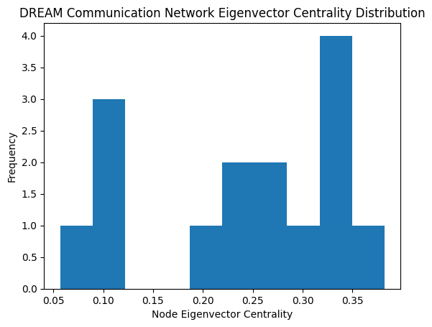

end-states to someone influential without having to go through too many intermediaries.

## Help Network

The help network (see Figure 5) is directed, weighted, and, unlike any other DREAM network, disconnected. This is a combined result of my inability to estimate the outgoing edgesof non-respondents *Figure 5: DREAM Help Network* for the help network and the recent arrival of the new secretary in the organization. Since they were so new to the organization, it makes sense that none of the more experienced members of DREAM would go to them for help, as opposed to the two other non-respondents: the executive director and the CFO.

Since spectral clustering is primarily used on undirected graphs, I replaced it with the greedy modularity[20] method of community detection.[21] Greedy Modularity and Louvain agreed on where to cut the network except in the case of the advocacy intern. The advocacy intern was again assigned to the legal team community (blue) by Greedy Modularity and to the advocacy team community (red) by Louvain. The new secretary was assigned to their own community since they were a disconnected component (purple). The help network is notably the first in which either method assigned the executive director to the advocacy team community. This seems to be because members of the legal team typically go to one of the several legal leaders (legal director, office manager, education director) before going to the executive director for help.

This could be due to either a lack of approachability of the executive director due to their position, or a lack of accessibility to the director as a result of their physical position in the office and their frequent absence from the office. The latter seems more likely since the executive director does not fit the profile of being unapproachable in my analysis of DREAM’s culture. For example, his ability to start casual conversations with employees in the office on topics as sensitive as relationship problems implies they are in fact, very approachable. However, the fact that their office is the farthest away from the legal department and that they are often out of the office engaging with media, politicians, or volunteers in the community, might explain why advocacy team members go to him for help more frequently.

It is also interesting to note that, despite being the most senior member of the organization and the mother of all three directors, the CFO has very few incoming edges. It is possible that the executive director would have reported asking her for help, however, the fact that only one of the two remaining children reported asking her for help “sometimes” is a sign that her transition out of the organization has progressed very far. 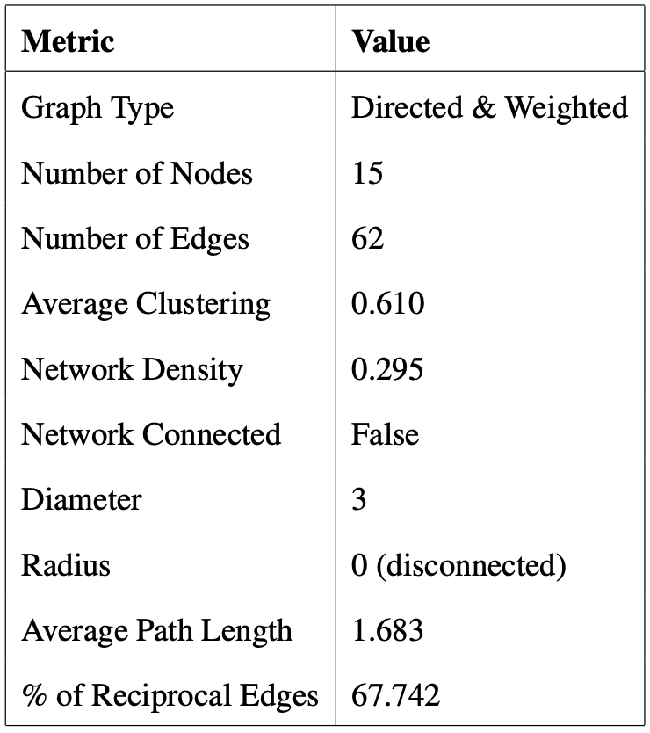

The help network has 62 edges for a density of 0.295 (see Table 5 for full network statistics). The density is significantly lower than that of the communication network because the communication network was not calculated as a directed graph and therefore had half as many possible edges for 15 nodes. Furthermore,

*Table 5: Help Network Statistics* soliciting help is more likely to go one way than communication or trust. Suitably, the percentage of reciprocal edges (how many people are also asked for help by people whom they ask for help) in the help network is 67.74%, lower than in the communication and trust networks (99.08% and 80.76% respectively). This is not too concerning when we take into account what characteristics of the help network make it most useful to the organization.

Help is a concept that, unlike communication, relies less on flowing throughout the network in order to pass information from one community to another. Instead, nodes’ immediate neighbors are much more important since help will usually only occur between two nodes, as opposed to communication which can be concerned with the flow of information from one end of the network to another. Therefore, the most important centrality distributions to pay attention to in the help network are the in and out-degree distributions (see Table 6 for the summary of all the centrality distributions).

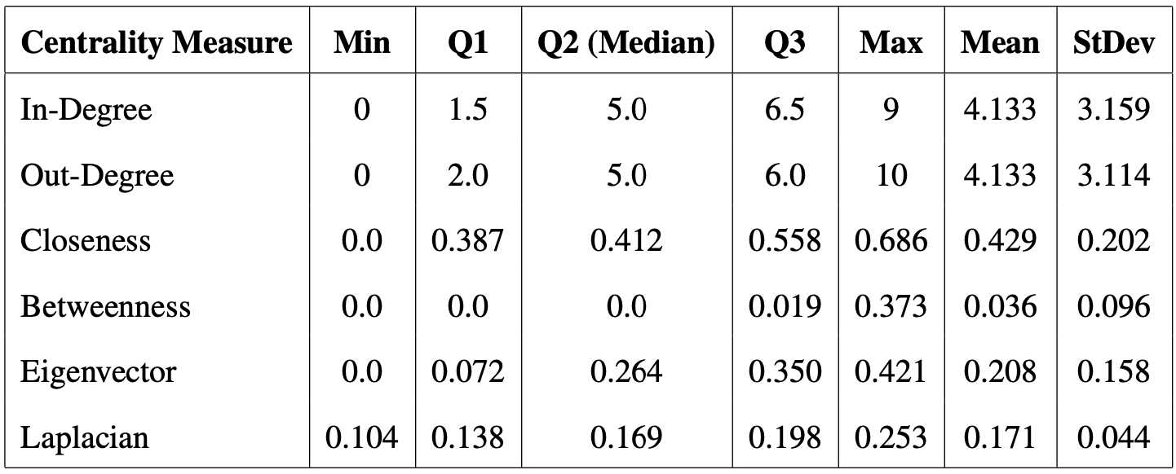The in-degree distribution (see Figure 6) appears to be fairly flat, which suggests that there are a few “experts” at the top that receive requests for help from

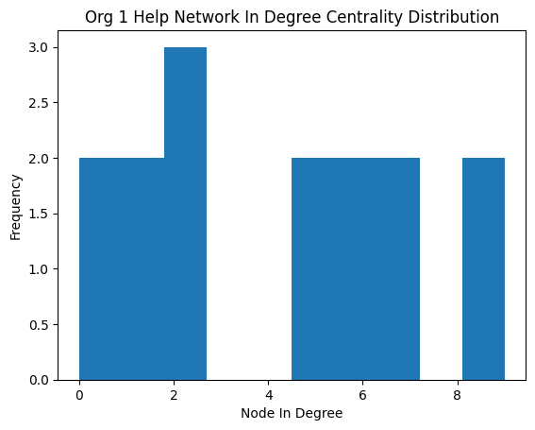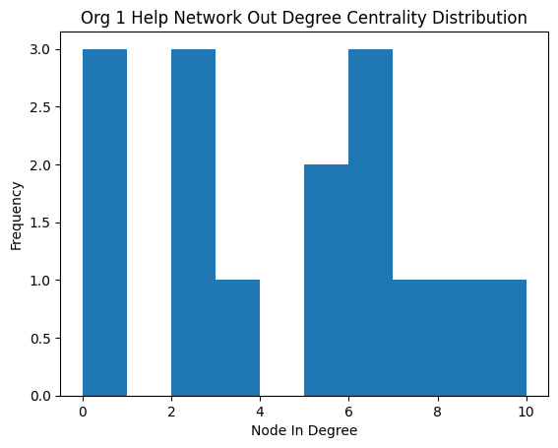 *Table 6: Help Network Centrality Distributions Summary* more than half of the network (max = 9), but there are also many other members of the organization who are seen as reliable and asked for help by a significant number of other members (Q2 = 5).

*Figures 6 & 7: Help Network In-Degree Centrality (left) and Out-Degree Centrality (right) Distributions*

This aligns with our understanding of the legal team having various leaders who can step in for each other and provide support for the entire team in the event of another’s absence.

The out-degree distribution (see Figure 7) is not as flat, however, it is important to note that the three individuals with an out-degree of 0 were the nonrespondents for whom I could not correct the data, and in the true distribution would likely be mixed into the rest of the distribution. Excluding the nonrespondents, the minimum out-degree in the network is 2, which means that every member of DREAM is comfortable asking at least 2 other members for help. Furthermore, since the 4 individuals without degrees between 2 and 3 were the volunteers within the advocacy team, we can exclude them to gain an understanding of the distribution of full-time employees and interns. At that point, the minimum out-degree is 5, which means that in the office, more DREAM members are accessible, and everyone feels comfortable with asking at least 5 people for help. This is a very healthy culture and means it is very unlikely that any DREAM office members would not have anyone to turn to with questions in case one or two other members called in sick or were unable to work for any reason.

One thing to keep in mind about the way that I collected the help data is that my survey asked about the probability with which they would ask another member for help if they encountered a need for it while going about their work. It did not measure the actual frequency with which individuals ask or are asked for help in a given week. It may have been more useful to ask about frequency to get an understanding of what happens on a day-to-day basis, but my approach allows us to understand which members are viewed as experts as opposed to which have the highest burden on them to help others.

## Trust Network

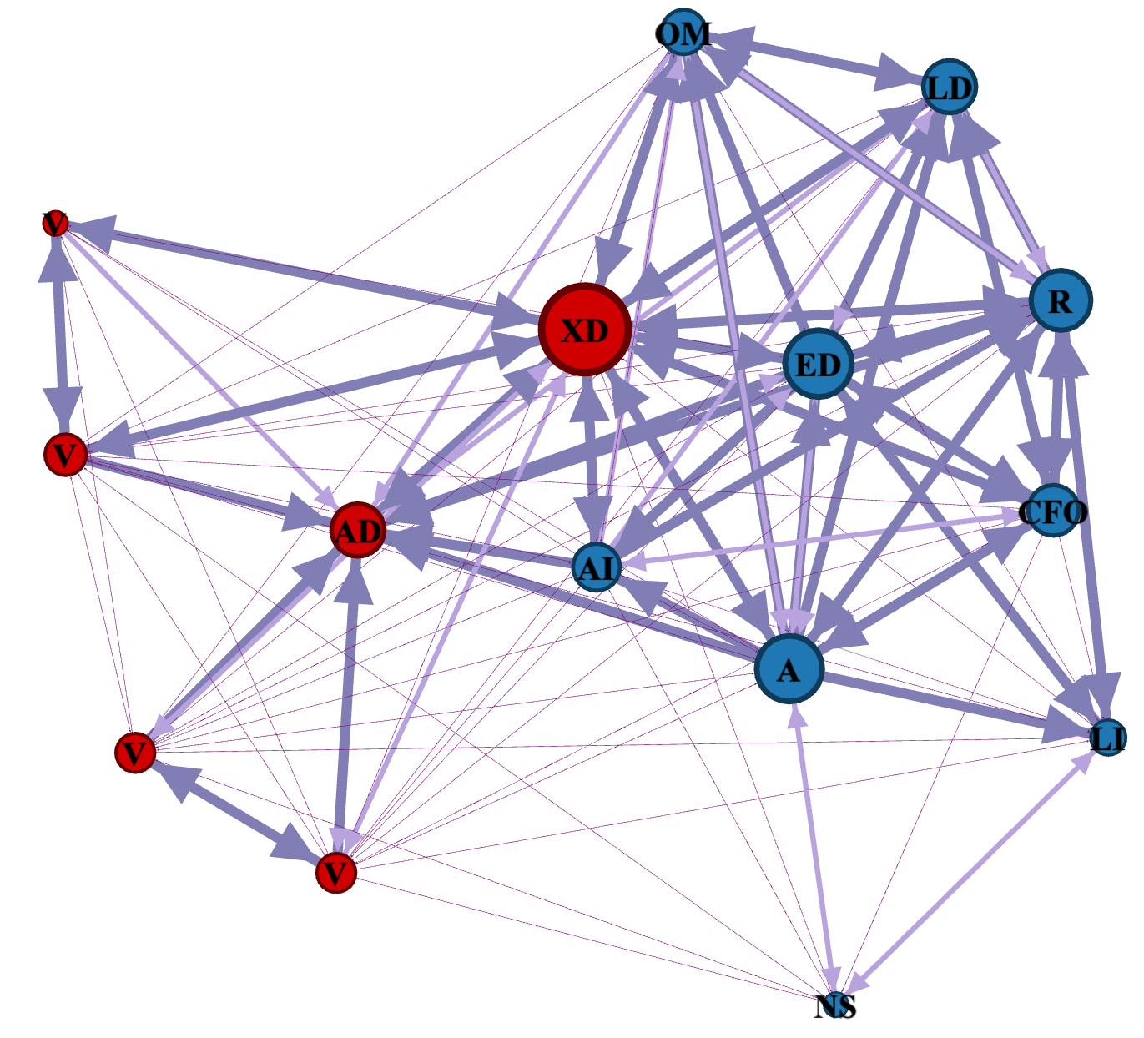The DREAM trust network (see Figure 8) is directed, weighted, and adjusted for non-respondents. Due to literature on the reciprocal nature of trust[22] and my qualitative observations on the culture of trust in DREAM, I decided to set the nonrespondents’ outgoing edges to a node to the same weight as any incoming edges from that node. The resulting network has 151 edges for a density of 0.719 (see Table 7 for full network  *Figure 8: DREAM Trust Network*

statistics). This is a very high density for a directed network with a reciprocity of about 80.8%. Furthermore, there is a relatively high average clustering coefficient of 0.782 in the network which, in conjunction with high density 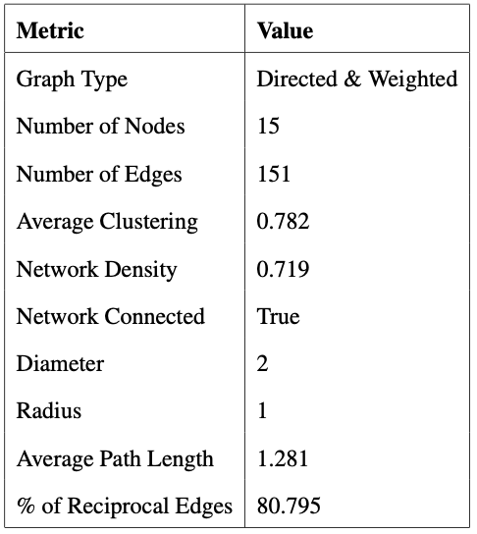and reciprocity, is a strong indicator of the high levels of trust that come from the very strong familial culture created by DREAM.

Running the community detection

*Table 7: Trust Network Statistics* algorithms resulted in similar results to the trust network communities, with the division being primarily between office staff and field staff as opposed to between the legal team and the advocacy team. Louvain split thenetwork with the advocacy co-director and all four volunteers in one community (red) and all the other members in the second community (blue). Greedy modularity, on the other hand, sorted the executive director into the advocacy community instead of legal.

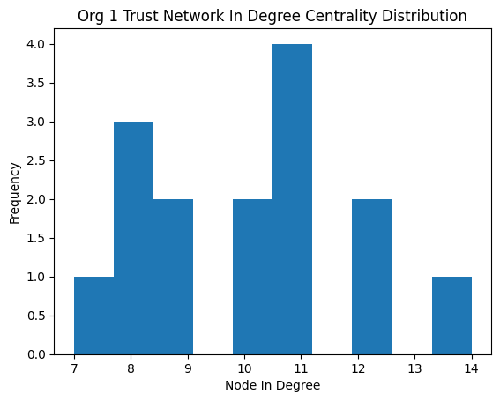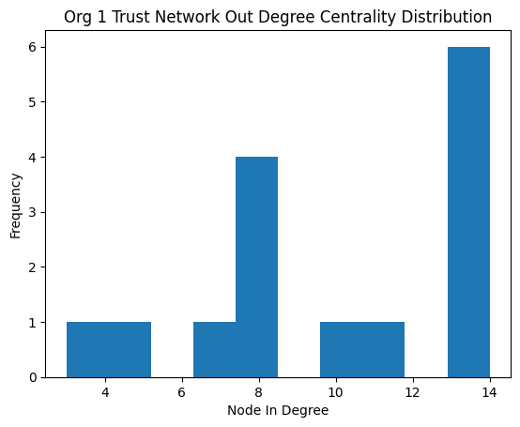The distribution of centralities in the trust network is also quite different from those of the other networks. For similar reasons to the help network, the centralities most useful to understanding trust are those that have to do with immediate neighbors (see Table 8 for the summary of centrality distributions). The in-degree distribution is normally distributed with a minimum of 7, which is quite a significant metric (see Figure 9). With the total number of nodes in the network being 15, that means that there is a maximum of 14 incoming *Table 8: Trust Network Centrality Distributions Summary*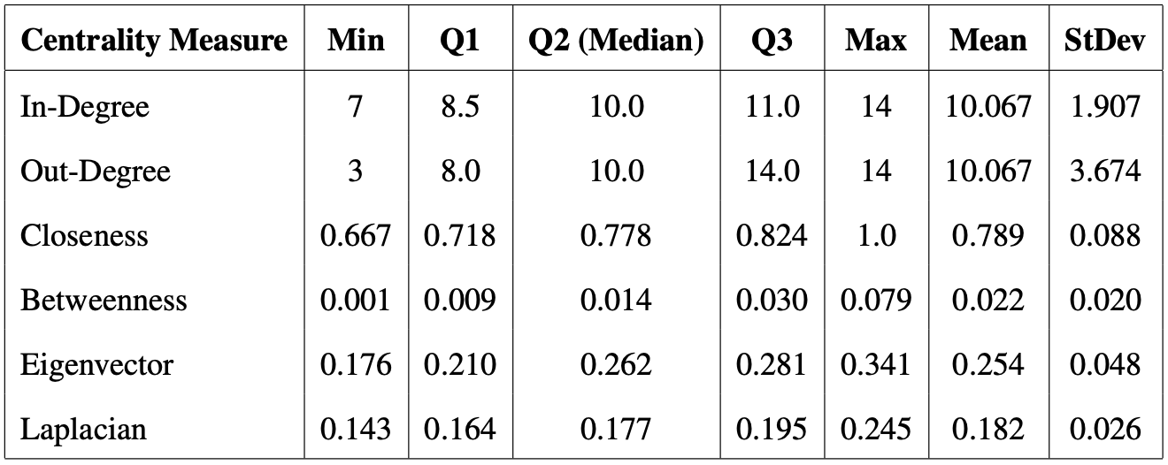

*Figures 9 & 10: Help Network In-Degree Centrality (left) and Out-Degree Centrality (right) Distributions*

edges since we exclude self-loops. For the least trusted individual in DREAM to be trusted by half of the organization is very impressive, especially considering how siloed volunteers are from the rest of the network.

The out-degree distribution is left-skewed, with a minimum of 3 and a median of 10 (see Figure 10). It is interesting that there would be some individuals who trust as few as 3 others in the network, however, this could be a dynamic where the isolated volunteers do not know and therefore do not trust other members of the organization, but employees who are closer to DREAM trust anyone affiliated with the organization due to a stronger in-group mentality or as a result of the similarity heuristic.[23] It could also be a result of social desirability bias since the survey was administered after I had gotten to know the members of DREAM for about a month, and they did not want to come across as untrusting despite the anonymization of the survey. However, it is also possible that this is a result of different understandings of the survey. Perhaps most respondents rated unknown members as “1 - neither trust nor distrust” as opposed to “0 - do not trust,” but 2 members understood a rating of 0 to be the baseline for people whom they did not know.

Regardless, only 2 members have an out-degree lower than 7, indicating that these are outliers. Furthermore, the mean and median are the same for both distributions (10 and 10.067 respectively) and both distributions still support the conclusion that DREAM had a very strong culture of mutual trust.

## Pearson’s Correlation Coefficients

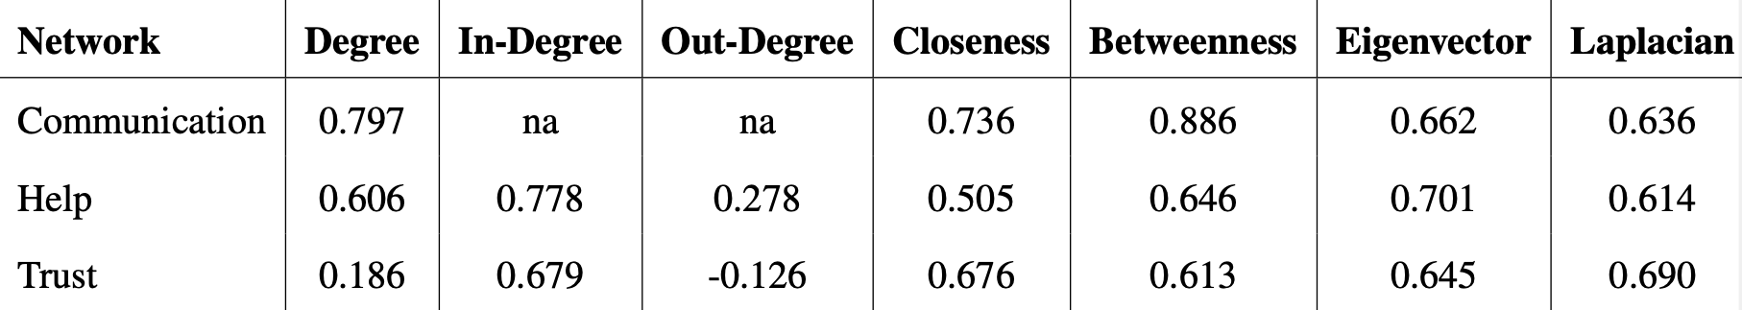Although DREAM was not an organization heavily reliant on its formal structure, I wanted to measure the impact of the structural network on the centralities of the other three networks. In order to do so, I calculated the Pearson correlation coefficients[24]of the centrality vectors of the communication, help, and trust networks compared to the corresponding vectors in the structural network (see Table 9 for the full results).[25] The rationale of this approach is that, in a well-structured organization, I would expect the centrality of the nodes in the communication, help, and trust networks to be aligned with their centrality in the structural network. This would happen because formal assignments are directly translating into, *Table 9: Pearson’s Correlation Coefficients of DREAM Networks vs. Structural Network*

communication, mentorship (help), and trust.

The strongest correlation was that of the betweenness centrality vectors of the structural and communication networks (0.886). Considering that the betweenness centrality distribution in the communication network pointed to a vulnerability in the bridges of the network as I explained above, it is possible that the formal structure plays a part in it and that a possible solution would be to increase the number of connections in the formal structure and create more bridges in the network. This conclusion is in line with my other findings in this chapter and Chapter II that DREAM has room to improve in areas such as its formal hierarchy that fall under the structural lens.

The weakest correlations were between the undirected degree and out-degree vectors of the trust network with the degree vector of the structural network. This initially makes sense since the trust network was by far the most dense network and the structural network was the least dense. However, this does not explain why the trust network’s in-degree vector has a correlation of 0.679 with the structural degree vector. This may be because it is difficult to accurately compare degree vectors of undirected and directed graphs. Comparing in and out-degrees to undirected degrees measures two slightly different values while converting directed degrees to undirected degrees misrepresents the nature of the connections. Therefore, I hesitate to give much weight to the Pearson’s Rs of the help and trust degree vectors.

Excluding them, the lowest correlation is between the closeness centrality vector of the help network with its counterpart in the structural network (0.505). This does not come as much of a surprise since the structural network’s closeness centrality distribution is skewed right and the help network’s is skewed left (see Figures 11 & 12). However, this is neither very significant nor is it concerning considering the nature of help, as discussed above. Since closeness centrality measures the shortest paths between nodes in a network is it more important for networks like communication, where the speed of information reaching different parts of the network is important. 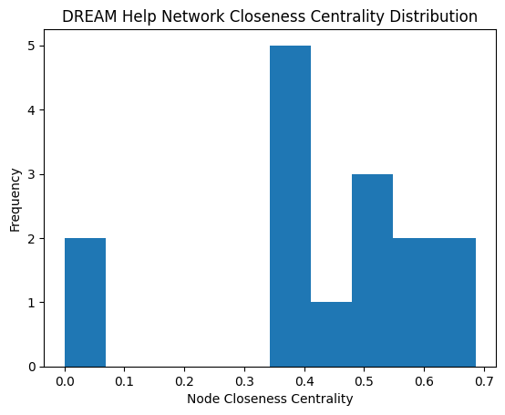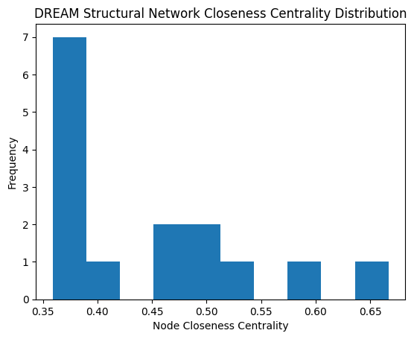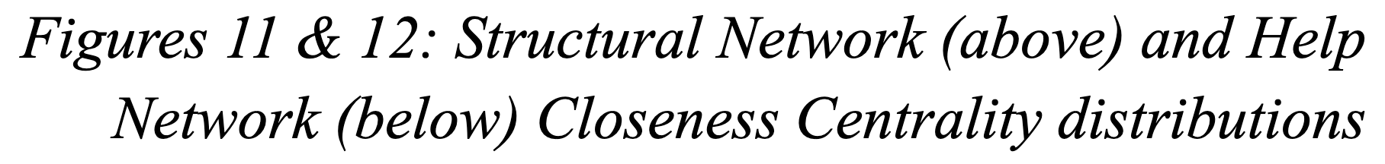

The average of all the Pearson’s Rs, excluding the ones measuring the three degree vectors of the help and trust networks,[26] was 0.672. The average score suggests that the structural network is moderately correlated with the structures of the other networks. This continues to be in line with my analysis that DREAM’s structure is not as influential as it could be, and serves as an area of improvement for the organization.

## Summary of Network Analysis

The social network analysis of DREAM focused on the relationship between its formal and informal structures via the structural and communication, help, and trust network respectively, the influence of individual members on the organization, and potential vulnerabilities due to their centrality and division between the office and field components of the organization. My main conclusions from the comparison of the formal and informal networks were that formal structures in DREAM were not maximizing their potential, and that, nevertheless, DREAM’s familial culture was represented very strongly.

High variance in betweenness centrality between a couple of leaders and the rest of the network indicates the critical role of those leaders in facilitating connectivity in the organization. The placement and accessibility of leaders, particularly in the help and trust networks, underline their influence on organizational dynamics. The reliance on these key individuals for connectivity, particularly in the communication network where information flow is the biggest concern, poses a risk to the organization's resilience to unexpected circumstances that might render these leaders unavailable.

One unexpected finding relating to the division of the network was that instead of the primary division being along formal team assignments, the primary location of involvement in DREAM seemed to be a more significant predictor of which community the spectral clustering, Louvain, or greedy modularity algorithms would sort an individual into. This was primarily demonstrated by the advocacy intern and the executive director. The advocacy co-director, despite being present in the office and serving as a strong bridge with the legal team, was consistently sorted into the advocacy community due to being the primary point of contact with volunteers. This supports my suggestion that volunteers, even when invited into the office, are siloed off from the rest of the organization and could be one of the reasons why volunteer consistency is so low.

Generally, this chapter provides an example of how self-reported communication, help, and trust levels can be used to construct representative networks of an organization and offer methodological insights into how quantitative data can inform the analysis of organizational dynamics. Unfortunately, adjustments had to be made for non-respondents and the rationale around these adjustments reflects the challenges of conducting network analysis, which would only be amplified by applying this approach to a larger organization. However, my findings shed light on the potential benefits of leveraging network analysis to identify strengths and areas for structural improvement within organizations.

# Chapter IV: Novel Metrics for Social Network Analysis

In this chapter, I introduce eight new metrics for analyzing social networks, specifically focusing on the structural, communication, help, and trust networks that I collected during my fieldwork. These metrics aim to provide alternative forms of quantitative insight into aspects of the three lenses within organizations which can be gathered through simple surveys. I then apply them to DREAM and discuss how the results relate to the observations and analysis I made.

## Preliminaries and Definitions

Before going into the details of the metrics, I define the basic notation and variables that I will be using.

Graphs and Notations:

• A graph is denoted as *G* = (*V, E*), where:

– *V* represents the set of vertices (or nodes) in the graph.

– *E* represents the set of edges (or links) connecting the vertices in the graph.

• Let *Gs*, *Gc*, *Gh*, and *Gt* denote the structural, communication, help, and trust graphs, respectively.

• Subscripts *s*, *c*, *h*, and *t* denote variables pertaining to each of these graphs, respectively.

Common Variables:

• *nz* represents the number of nodes in graph *Gz*

• *ez* represents the number of edges in graph *Gz*

• *c*(*i*)*z* represents the clustering coefficient of node *i* in graph *Gz*

• *Cz* represents the global clustering coefficient of graph *Gz*

• *CC*(*i*)*z* represents the closeness centrality of node *i* in graph *Gz*

• *BC*(*i*)*z* represents the betweenness centrality of node *i* in graph *Gz* 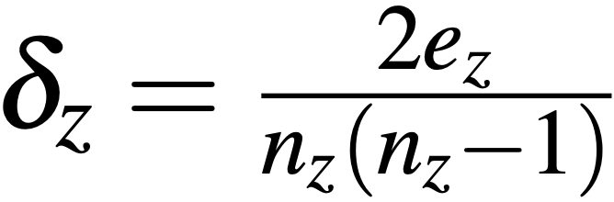

• *δz* represents the density of graph *Gz*, calculated as for undirected graphs.

• The mean closeness centrality for each graph, *z*, is defined as: 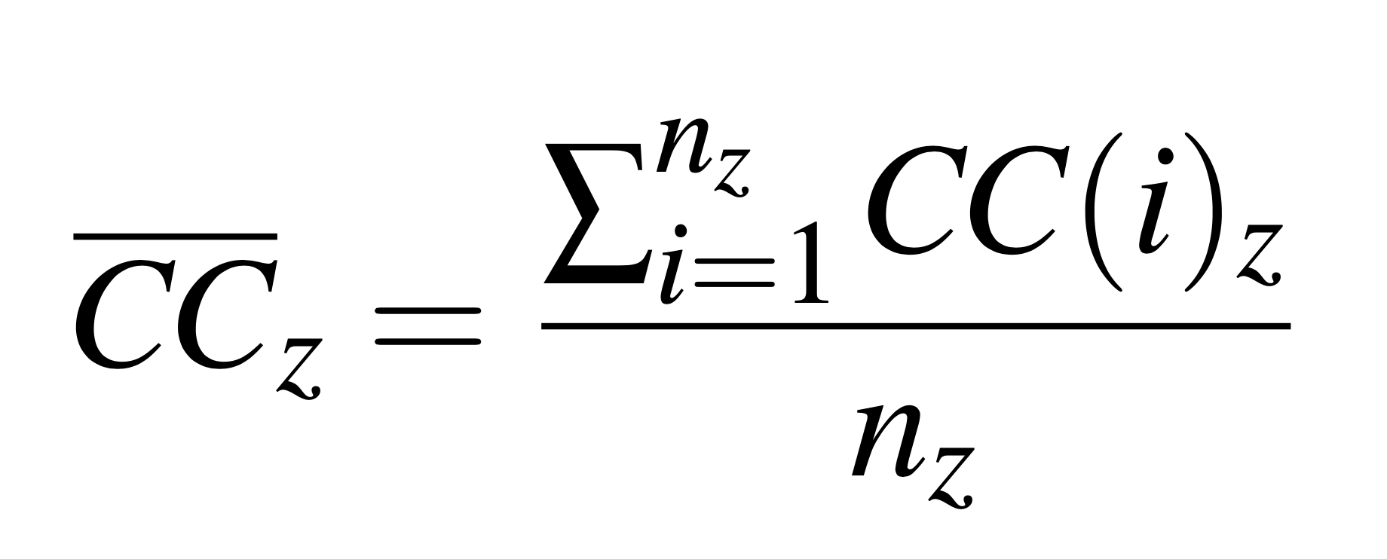

## Connectivity Scores (*CSz*)

The first metrics I propose are connectivity scores (*CSz*). The connectivity scores for structural (*CSs*), communication (*CSc*), and help (*CSh*) networks share a common formula, reflecting the average of mean closeness centrality and graph density. I do this in order to balance the value of direct ties between nodes and the value of shorter paths between disconnected nodes while lowering the effect of outliers which takes place when calculating the mean closeness centrality. They are defined as follows: 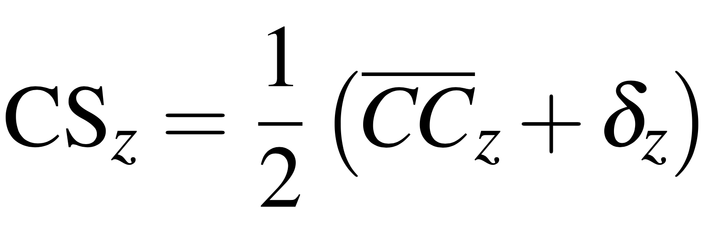

where *z* is replaced with *s*, *c*, or *h*, for the structural, communication, and help, respectively. This formula combines the importance of individual node centrality with overall network density, providing a score that ranges from 0 to 1, with 0 representing a network with the least possible connectivity, and 1 representing a network with the most possible connectivity.

The connectivity scores show promise as more balanced indicators of connectivity when there is a discrepancy between density and closeness centrality in networks with medium densities. In order to identify where my connectivity scores serve as better individual metrics of connectivity in social networks, I ran several simulations which found that there is a large discrepancy between network density and average closeness centrality in networks of all sizes around when their density is between 0*.*1 and 0*.*7. The average discrepancy of networks where *n* = 15 (the size of the DREAM networks) was 0.176 with a standard deviation of 0.054 when 0*.*1 *< δ <* 0*.*7, and was even larger when *n* was set to 500 and above, with the average discrepancy being 0.255 with a standard deviation of 0.105 (see Appendix C for more analysis). Therefore, I recommend the connectivity scores as alternative individual metrics of connectivity in networks of medium and progressively low densities as the networks grow in size. The connectivity scores have a minimum score of 0 and a maximum score of 1. A score of 0 would occur in a network with no edges at all, and a score of 1 would occur in a complete network, where every node is connected to every single other node.

## Mutual Trust Score (*MT*)

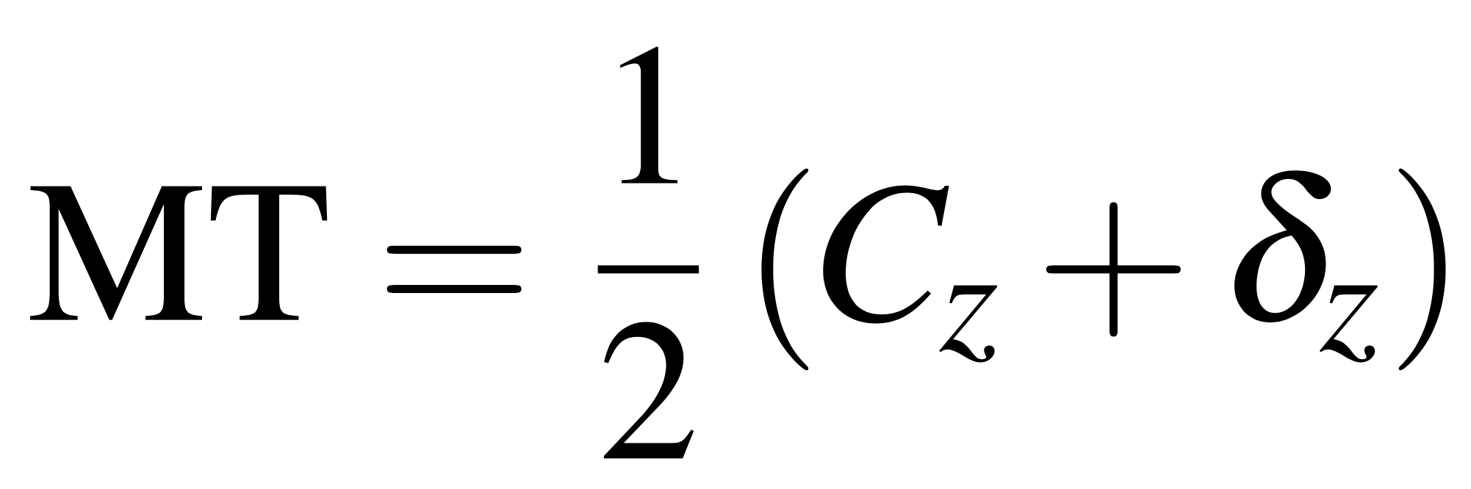When evaluating trust in a network, I argue that the closeness centrality is not as important as it is in evaluating a characteristic like communication. When evaluating communication, the speed of information flow from one end of the network to the other must be taken into consideration. However, as trust travels through a network it dilutes much more significantly than communication does, and connectivity is therefore less important.[27] I propose that measuring trust between individuals as well as whether individuals’ neighbors trust each other is equally important. Therefore, the mutual trust connectivity score *MT* is defined as follows:

This formula is the same as the one for *CSz*, however, I have replaced average closeness centrality of the trust network (*t*) with its global clustering coefficient (*Ct*). By using the global clustering coefficient, I shift the focus of the first part of the equation from measuring the efficiency of flow throughout the network, to evaluating the network’s propensity to create clusters. By keeping density as a component of the metric I still account for the importance of a fully connected network and minimize the risk of the score favoring segregated communities that trust each other but not the rest of the organization. The help network also requires a customized connectivity score for a similar reason, which I will define later in this chapter. Like the connectivity scores, it has a minimum of 0 and a maximum of 1.

## Bridge Vulnerability Score (*BV*)

Another new metric I propose is the Bridge Vulnerability Score (*BV*). It attempts to assess how reliant an organization is on a select few individuals who act as bridges within its network structure. The metric is calculated by sequentially removing the 3 nodes with the highest betweenness centrality *BC*(*i*)*z*, recalculating the average path length (*L*), and then summing the changes in *L* with diminishing weights *Wv*. The BV score is normalized so that a value of 1 corresponds to the scenario where the network becomes disconnected after the removal of the first node, indicating maximum vulnerability. The BV score is defined as: 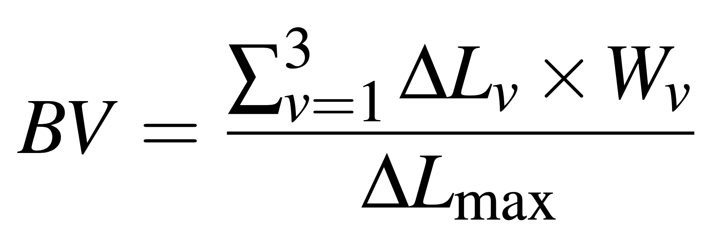

Where *Wv* = *{*1*,*0*.*5*,*0*.*25*}* for *v* = *{*1*,*2*,*3*}* respectively, representing the diminishing weights applied to the changes in average path length for each of the three sequentially removed nodes. The term ∆*Lv* = *L*new *−L*original captures the change in average path length, where *L*new and *L*original are the average path lengths after and before the deletion of each node, respectively.

The normalization factor, ∆*L*max, is determined based on the change in *L* that would result from the network becoming disconnected after the removal of the node with the highest betweenness centrality. This would typically be observed when the first node’s removal results in the highest possible increase in *L*, leading to disconnection of the network (an increased path length of infinity). If the network does not become disconnected after the removal of the first node, ∆*L*max is set to the largest ∆*Lv* observed within these removals to ensure the BV score is properly scaled between 0 and 1, where 0 would represent no increase in path length and therefore no reliance on bridges (due to it being a complete graph) and 1, which represents the network immediately becoming disconnected after deleting one node.

I chose the approach of deleting high betweenness centrality nodes *BC*(*i*)*z* because betweenness centrality is typically used as an indicator of whether nodes serve as connectors in their network.[28] By recalculating the average path length (*L*) while progressively discounting the effect for each deleted node I represent the decreasing likelihood that two individuals would be compromised at the same time. I also maintain an emphasis on the risk of losing the most important bridges. I choose to normalize the BV score to allow for consistent comparison across networks of different sizes.

## Inter-Community Density (*ICδz*)

The last metrics I propose deal with measuring connectivity between the communities of a network. The two specific scores I define are the Inter-Cluster Density and the Inter-Cluster Leader Communication Score. The Inter-Community Density metric (*ICδz*) is a statistic nearly identical to the traditional density metric *δz*, but only takes into account the possible and existing edges between nodes in different communities. It is defined as:

Given a graph *G* = (*V,E*) divided into *nC* distinct communities *{C*1*,C*2*,...,Cn}*, the Inter Community Density is calculated as:

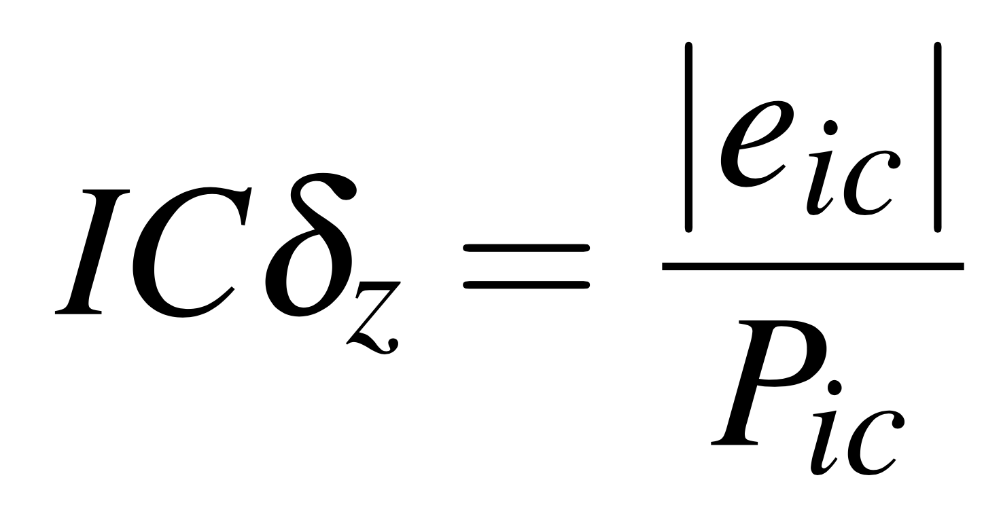

where:

• *|eic|* is the total number of actual inter-cluster edges, defined as edges connecting nodes belonging to different communities.

• *Pic* represents the total possible number of inter-cluster edges, calculated as the sum of all potential connections between nodes of different communities: where *|Ci|* and *|Cj|* are the sizes of communities *Ci* and *Cj*, respectively.

*ICδz*’s value can range from 0 to 1. A score of 0 represents no inter-community connection, where either the network is disconnected or there is only one community. A score of 1 represents a scenario where all nodes in different communities are connected, implying a complete graph.

## Inter-Community Leader Density (*ICδzLeaders*)

The Inter-Community Leader Density metric (*ICδzLeaders*) is a slightly modified version of inter-community density. It focuses solely on the connectivity between the most central nodes of each community; this score highlights the role of leaders or key nodes in facilitating inter-community communication. I defined leaders as the nodes with the highest degree centrality within each detected community. The inter-community leader density is then calculated based on the connections between these leaders as follows: 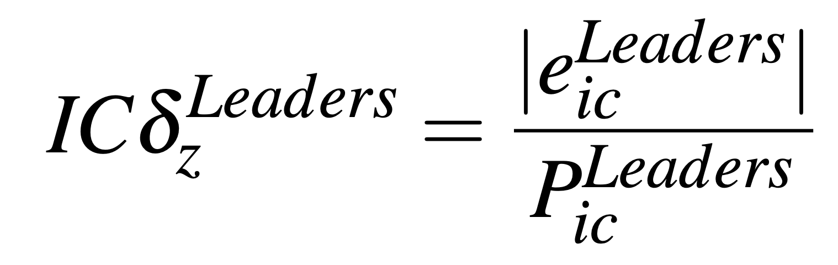

where:

• *|eicLeaders|* is the count of actual edges connecting the highest degree centrality nodes across different communities.

• *PicLeaders* is the total possible number of edges between these high-centrality nodes, theoretically one potential edge for each pair of communities, thus: *PicLeaders*= , since we are only considering one leader per community. 

*ICδzLeaders*, like *ICδz*, can range from 0 to 1 and can be interpreted in the same way, except in the context of the leaders of different communities in the network. Both scores offer insight into how communities within the network interact, either broadly or through key individual connections, providing a nuanced understanding of the network’s structure and potential pathways for information flow or influence. Furthermore, I incorporate inter-community density into the continued discussion of my proposed connectivity scores. It has a minimum score of 0 and a maximum score of 1.

Unlike the general *ICδz* metric, a score of 0 does not imply a disconnected graph, and a score of 1 does not imply a complete graph. A connected network could score 0 on *ICδzLeaders* if none of the bridges between communities had the highest degree centrality in their respective communities. Conversely, a network with a very low density could score 1 if the only inter-community edges were between the nodes with the highest degree centrality in their respective communities.

## Mutual Help Score (*MH*)

Help and trust networks are different from communication networks in similar ways. As I mentioned in the section on the mutual trust score (*MT*), average closeness centrality is a metric for the efficiency of flow through a network. While help can indeed travel across an entire network, this would occur in instances where several individuals in a row do not know how to help and must continue asking others. Based on my observations, this is not very common. Therefore, I opt to use the average clustering coefficient of the help graph (*ch*). The mutual help score is defined as follows:

MH = *h ×ICδmodifier*

where:

• *h* is the average clustering coefficient of the help network 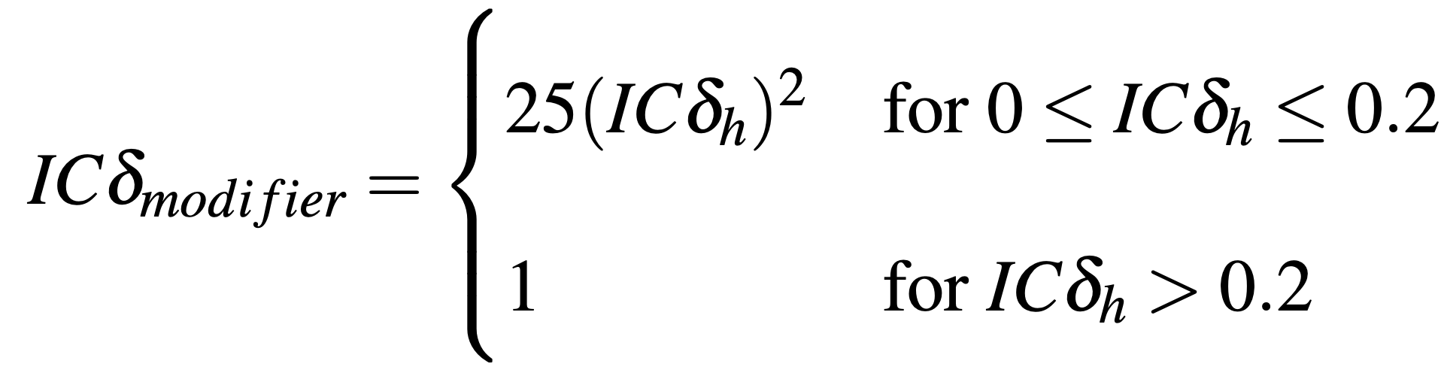

•

• The piecewise function lowers the overall score by a magnitude that decreases as the inter-community density of the help network approaches 0.2.

The inclusion of the average clustering coefficient in the score favors the propensity of individuals in similar roles creating tight-knit groups that support each other. I also include the help network’s inter-community density via the modifier (*ICδmodifier*) in order to account for the importance of collaboration between teams which can lead to more innovation within the organization.[29] The modifier lowers the score significantly when there is little to no inter-community connection and progressively lowers the score by less as the help network’s inter-community density approaches 0.2, after which it has no effect. I only value it below 0.2 because complete inter-community density is not necessary in order to foster cross-community collaboration and I am wary of discounting the score by too much when there is still a meaningful connection between communities. It has a minimum score of 0 and a maximum score of 1.

## Informal Connectivity Score (*CSinformal*):

Using the base connectivity scores, I then propose an informal connectivity score (*CSinformal*) which averages the communication and help network connectivity scores to estimate the level of informal connections within an organization.

*CSinformal* =(*CSc* + *MH*)

## Formal-Informal Discrepancy Score (*FID*):

Next, I propose a Formal-Informal Discrepancy score (*FID*) that measures the difference between the formal connections established by the structural network and the informal connections in the communication and help networks by subtracting *CSinformal* from *CSs*. It is defined as:

*FID* = *CSs −CSinformal*

My objective with this score is to provide a description of how much activity is occurring in the organization beyond the formal hierarchies and teams established by upper management. The score can range from -1 to 1. A positive score is likely to be concerning because it implies that there are connections that have been outlined by upper management in the formal network that do not result in actual communication or consultation between those individuals in the organization. A negative score could be interpreted in various ways depending on the context and/or the desired state of the organization, but overall implies that there is informal activity occurring between individuals not formally directed to collaborate.

## Relational Coordination Score (*RC*)

Last in the series of connectivity metrics is a score based on the Relational Coordination (*RC*) Survey.[30] It attempts to estimate a measure of relational coordination within an organization by using the connectivity and mutual trust scores as proxies for different questions in the RC survey and weighing them by how many questions they serve as a proxy for. I omitted question 6 on shared knowledge from my metric because I did not collect data to construct an appropriate network to use as a proxy.

I use the communication network connectivity for questions 1-3 on frequent, timely, and accurate communication and weigh it as 50% of the score since it serves as a proxy for 3 out of 6 questions. I use the help network connectivity for question 4 on problem-solving communication and weigh it as 17% of the score because it serves as a proxy for 1 of 6 questions. Finally, I use the trust network connectivity for questions 5 & 7 on shared goals and mutual respect and weigh it as 33% of the score since it serves as a proxy for 2 out of 6 questions. The RC score is defined as:

*RC* = 0*.*5*×CSc* +0*.*17*×MH*+0*.*33*×MT*

Like all the other connectivity scores, it has a minimum of 0 and a maximum of 1, with the former representing the lowest level of relational coordination, and the latter representing the highest level of relational coordination

## Applications to DREAM

The metrics I propose both support the analysis of previous chapters and enhance it with new perspectives on DREAM using the three lens framework. See Appendix B for a summary of DREAM’s scores on my proposed metrics

## Structural Network Scores

The structural network is a good candidate for the application of my proposed metrics, beginning with the connectivity score. With its density of 0.210 and average closeness centrality of 0.447, it has a discrepancy near the peak of what would be expected in a network of 15 nodes based on my analysis in Appendix C (= 0*.*447, *δ* = 0*.*210,  *−δ* = 0*.*237).

The discrepancy of 0.237 was the highest I observed across my 4 networks. This is valuable to note because the structural network, along with the communication network, is a network where shorter paths between nodes are a desired characteristic due to the importance of recognizing information flow, as I explained in more detail in Chapter 3.

The structural connectivity score (*CSs* = 0*.*328) is in line with my analysis of the structural network in Chapters 2 and 3. DREAM’s neglect of a formal design is reflected in the low score, while still valuing the proximity of all nodes to each other, with the average path length in the network being 2.314. The structural connectivity score presents itself as a useful alternative metric of connectivity in the network.

/The structural network also provided interesting insights with the application of the Bridge Vulnerability score (*BVs*). The structural network’s *BV* was 1.000, which only occurs when the deletion of the node with the highest betweenness centrality in the network results in disconnection. The deleted node was that of the executive director, who is the only link to the advocacy director, and therefore the rest of the advocacy team, as well as the only link to the CFO. Since no other formal ties have been established to those two parties, any time the executive director is absent or unavailable, the network is disconnected, at least formally. Although this is not the case in practice as will be demonstrated by the communication network, it is another point of evidence in line with my analysis that DREAM’s formal structure relies too heavily on select nodes to act as bridges.

The final metric worth analyzing in the structural network is its inter-community density (*ICδs*). The DREAM structural network had a very low inter-community density of 0.019, which is connected to its very high BV score. The only inter-community edge in the structural network was the one connecting the executive director to the advocacy director. For an organization so reliant on flexibility (see Chapter 2), it is very important to have contingencies in place for situations where key individuals are not able to perform all of their tasks. Although DREAM is effective at handling unforeseen circumstances due to mutual understanding and willingness to fill gaps amongst leadership, enumerating interconnections in its formal structure could only solidify DREAM’s environment of flexibility.

In general, the scores from my new proposed metrics were in line with my observations of DREAM’s structure and structural network, and provide quantitative support more specific than is possible with general network statistics.

## Communication Network Scores

Like the structural network, the DREAM communication network is also a good template with which to test my proposed networks. In fact, it has a slightly larger discrepancy between density and average closeness centrality than I would expect based on my analysis in Appendix B due to a high average closeness centrality (= 0*.*683, *δ* = 0*.*495, *−δ* = 0*.*188). The discrepancy of 0.188 was the second highest observed, behind that of the structural network. As I mentioned in the section on the structural network, the communication network is a graph where shorter paths between nodes are worth considering due to the importance of information flow in evaluating communication.

The communication connectivity score (*CSc* = 0*.*589) is in line with my analysis of the structural network in Chapters 2 and 3. The physical layout of the legal team’s space created high density within their subgroup, and the advocacy director’s connection to many of the legal team members shortened the distance between peripheral nodes on both teams. However, the inter-community density score (*ICδc*) provides additional context for why the communication connectivity score is not higher. The communication network’s score was low, at 0.260, which indicates that it accounts for more of the missing density in the network than intra-community edges. Although this is intuitively based on principles of social networks, such as triadic closure, measuring the degree to which this occurs in specific networks opens the door for quantitative analysis of its trends and effects. Both metrics align with my observations in DREAM and enhance my analysis, especially when used in conjunction.

Additionally, the *BV* score provided interesting results when applied to the communication network. The communication network became disconnected after deleting the 3 nodes with the highest betweenness centralities for a score of 0.317. Since the score is normalized, it indicates that the communication network is not very vulnerable to the effects of bridges becoming compromised, but it is not immune either. This finding is yet again in line with my analysis in previous chapters. I established that DREAM had a very flexible informal structure and that multiple experienced leaders were able to fill each other’s roles in case they were absent. That is reflected in the fact that up to 3 leaders can be deleted from the network before it becomes disconnected and that the average path length only increases to 31.7% of the possible score (the percentage refers to the fact that *BV* is normalized to have a minimum of 0 and maximum of 1).

Applied to the communication network, my metrics again aligned with and quantitatively supported my findings in Chapters 2 and 3.

## Help Network Scores

In its custom metric *MH*, the help network scored at 0.571, with an average clustering coefficient (z) of 0.610 and an inter-community density (*ICδh*) of 0.194. Due to the modifier implemented into the *MH* score, the inter-community density lowered the final output only slightly, as it was approaching the modifier’s established threshold of 0.2. The metric performed as I had hoped, prioritizing close collaborative teams with the average clustering coefficient, and not heavily discounting the score since the inter-community density approached the threshold I set as meeting the standard for cross-community collaboration. This aligned with my observations of DREAM, although DREAM’s inter-community collaboration was slightly more one-sided than *ICδh* accounts for. Most collaboration came from the engagement of the executive and advocacy directors with the legal team except for one edge originating from the advocacy intern towards the secretary. None of the volunteers were connected to anyone on the legal team. Furthermore, the 3 non-respondents slightly decreased *ICδh* beyond what is likely its true value, especially when considering the outlier community as a result of the new secretary’s disconnection. Despite these considerations, *MH* did a suitable job of giving the help network a score that neither neglects network-level connectivity nor over-punishes its absence and can serve as a proxy that aligns with my observations.

The help network’s *BV* score was 1.000 because, like the structural network it became disconnected after the deletion of the node with the highest betweenness centrality. The deleted node was the advocacy director, and the disconnected component consisted of 2 volunteers. This is a concerning finding because, although the volunteers could ask each other for help and resolve issues together, the advocacy director is the only senior leader they had contact with. If the volunteers encounter a complex issue that was not briefed to them in any previous training and the advocacy director is unavailable, then they have nowhere else to turn. The *BVh* metric identified an important vulnerability in the help network in coherence with what I observed on the ground with DREAM, reinforcing its potential value in social network analysis.

## Trust Network Scores

The trust network’s adjusted connectivity score *MT* produced a value of 0.722 in the DREAM network. The trust network’s global clustering coefficient (*Ct*) was 0.724 and its density (*δt*) was 0.719. Since the trust network is fairly dense, both values are similar and either would have served as an appropriate proxy for trust in DREAM independently, however, I maintain that *MT* would be a more balanced metric in lower-density networks. *MT*’s high value is very representative of the strong familial culture I documented at DREAM as well as the high role flexibility amongst leaders. Without high levels of trust, directors would be less likely to be comfortable with other directors stepping in to fill their posts in their absence. The *MT* metric therefore serves as another illustrative metric in accordance with the Chapter 2 analysis of DREAM.

*BVt* also affirms my analysis that DREAM’s familial culture led to a great deal of mutual trust in its organization. The trust network remained connected even after the deletion of the nodes with the 3 highest betweenness centralities and its normalized *BV* was 0.038. This incredibly low score emphasizes the interconnectedness of the trust network and can be interpreted as the low probability that the network would ever become disconnected into two communities distrustful of each other. Correspondingly, *ICδt* was also very high, at 0.815. This is very high, particularly for a directed graph, and is yet another numerical piece of evidence for the observed levels of trust in DREAM. In sum, my proposed metrics continue to support my analysis in Chapters 2 and 3 when applied to the trust network.

## Combined Metrics and General Inferences

The first combined metric I introduce is informal connectivity (*CSinformal*), a combination of communication connectivity (*CSc*) and mutual help (*MH*). DREAM’s informal connectivity was calculated at 0.580. As a simplistic metric of how much activity is occurring in the network with the goal of comparing it to the structural network connectivity (*CSs*), it scores reasonably high given DREAM’s compartmentalization of its office and field teams. Subtracted from *CSs* it results in the formal-informal discrepancy score (*FID*) and scores -0.252. The negative score supports my conclusion that DREAM was underreliant on formal structure. However, its moderate value of -0.252 agrees with my analysis of Pearson’s Rs in Chapter 3 that the structural network still plays a meaningful role in affecting organizational behavior.

In my rudimentary Relational Coordination index, DREAM scored 0.629. Unfortunately, I did not collect data directly related to RC when I was on the ground with DREAM, and cannot accurately compare it to the original RC survey. However, based on the principle of RC that organizations perform better when their various components work in tandem, I maintain that my metric serves as an early indicator that measures of network connectivity can be applied as proxies for the various questions of the RC survey. In DREAM, I observed that relationships between its members were very strong (see the Chapter 2 cultural analysis). However, the organization was pretty strongly divided in the communication and help networks between its legal/office component and its advocacy/field component. These dualities could account for a medium-level RC score like 0.629. In order for my metric to be properly applied to RC, though, it would require more intentionality in the collection of data, such as the inclusion of a network that takes shared knowledge into account. Lastly, inter-community leader densities (*ICδzleaders*) did not prove to be very useful in such a small network with only 2 communities. All networks scored 1.000 when accounting for the outlier in the help network since I only considered one node in each community. For that reason, I do not include them in my analysis, however, I maintain that, in larger and more complex organizations with a large number of communities, it could be a useful metric of cross-community coordination that isolates leaders and could be adjusted to target leaders defined by any other metric, such as betweenness centrality.

In conclusion, all 4 of the connectivity scores (*CSz*) were higher than the densities that I used in my analysis in Chapter 3, albeit some by low margins. This provides additional nuance and avoids underestimating characteristics other than direct connection such as efficiency of travel in the network when evaluating connectivity. The bridge vulnerability (*BVz*) and inter-community density (*ICδz*) scores provided unique and useful quantifications of the relationship between the legal and advocacy teams. The metrics I propose show potential to illustrate organizational features based solely on the construction of the 4 networks I chose. However, I assert that they are best used in conjunction with fieldwork, qualitative observations, and analysis, similar to the one I conducted in Chapter 2, and can serve to provide an objective and quantitative framework for organizational analysis.

# Chapter V: Conclusion

## Limitations

Although this thesis provides an in-depth qualitative and quantitative analysis of the immigrant advocacy organization DREAM, there are several limitations to the study. These limitations extend to both the fieldwork and the network analysis.

The largest limitation of my thesis is its sample size. I had initially hoped to compare DREAM with another organization that conducted advocacy for transgender African Americans in the same city, however, I found that the organization was not nearly as active as DREAM and very few members responded to my surveys. The organizations were at very different operational levels and I was unable to construct even approximately representative networks of the second organization. A comparison of my proposed metrics across several different organizations accompanied by qualitative observations to explain and contextualize trends in the metric scores would make my proposal far stronger, though it would entail a herculean effort.

As discussed in Chapter 2, DREAM, and particularly its advocacy team, operate differently depending on the broader state-level and national context surrounding immigration. Having observed the organization for only one month during a somewhat stagnant period of immigration policy only allowed me to gain insights into one of DREAM’s operational states. If I had been with DREAM for longer and if an event of the same magnitude as the enactment of DACA had occurred, I would have been able to conduct a more complete study of how DREAM is able to mobilize all its resources in times of extraordinary need.

Another limitation of the thesis on the basis of time is that the DREAM networks are not dynamic, and only represent the organization at a single snapshot in time. If I had spent more time with DREAM and had been able to administer the survey every month, then I would have been able to track changes in centrality distributions, network densities, and all of my proposed metrics over time. This would have allowed me to evaluate how DREAM responds to its changing environment and demands, as well as what individuals play more important roles in different transitions and situations. Furthermore, a continued in-person presence would have made it easier to encourage nonrespondents to fill out the surveys. This was another limitation of my thesis, especially in the help network where I chose not to estimate outgoing edges from nonrespondents.

In addition to more timestamps, it also would have been more helpful to construct more types of networks. By only collecting structural, communication, help, and trust networks I limited my thesis from being able to analyze other organizational characteristics of DREAM. For example, if I had included questions on respect, shared goals, knowledge/awareness, and judgment, I would have been able to create a more complete RC metric. Furthermore, instead of solely focusing questions on communication on frequency, including questions about the timeliness and accuracy of communication would have made the communication network more insightful and applicable to Relational Coordination.

Aside from the *RC* score excluding a proxy value for question 6 of the RC survey on shared knowledge, there were other limitations to my proposed metrics. Various weights within my formulas such as the ICδmodifier threshold of 0.2 and the equal averaging of z and δz in the Connectivity Scores were set arbitrarily and could be calculated more rigorously.

Lastly, my network analysis was bounded by DREAM members and thereby did not take into account individuals’ connections with external actors, which can be equally important. For example, the executive director’s connections to local politicians and the education director’s connections to college counselors and education representatives in the area are not represented in any of their centrality values.

## Potential Future Work

There are several ways in which future work bridging organizational and social network analysis can build upon this thesis beyond addressing the limitations. One network feature that I did not experiment with was the concept of node attributes. Utilizing attributes to represent different positions or team assignments of nodes could allow for more insights into the relationships between positions and departments within organizations. Furthermore, the collection of more types of networks, such as shared knowledge and respect, opens up the possibility for further novel metrics for social analysis tailored to the nature of each organizational feature.

DREAM exhibited similar traits to those of a startup company, with its flexibility of roles and ability to mobilize resources to meet extenuating circumstances. Future work could combine a similar format of qualitative and quantitative analysis in order to try and develop correlations between characteristics of startups and voluntary associations both along the three lenses as well as with network analysis, including my proposed metrics.

## Final Summary

This thesis embarked on the quest to bridge the fields between more qualitative schools of organizational analysis, in particular the three lenses framework, and the quantitative world of network theory within the context of the voluntary association DREAM. Through each of its 3 approaches, it uncovered many unique aspects about the organization and the process of analysis itself. In Chapter 2, I highlighted the broad effects of DREAM as an organization founded and run by a single family. These effects extended to its culture of strong mutual trust and, in tandem with leadership’s shared experiences throughout the years, its impressive flexibility and the capacity of its leaders to fill any gaps on a moment’s notice. However, I also identified how the familial structure and high adaptability led to an under-reliance on formal structures in the organization, an insight that became evident in my quantitative assessments of DREAM.

One of the most prominent findings in Chapter 3 was the massive gap in betweenness centralities between one or two select nodes and the rest of the network in all networks except for the trust network. This was an early indicator of an overreliance on a few individuals to serve as bridges for the entirety of the organization, a finding that was elaborated on in Chapter 4. Another interesting conclusion of Chapter 3 came from the community detection algorithms. As was hinted at in Chapter 2, DREAM was not so much divided by its two largest teams, legal and advocacy, but more so by the nature of members’ work. The spectral clustering, Louvain, and greedy modularity algorithms that I used to detect communities in the networks sometimes grouped DREAM members who primarily worked in the office together, and DREAM members who primarily worked in the field together. The most notable example of this was the advocacy intern in the trust network.

Finally, Chapter 4 provided additional support for the findings of Chapters 2 and 3 through its custom metrics. For example, the observed overreliance on bridges I noticed in the earlier analyses was confirmed by the bridge vulnerability metric *BVz.* The structural and help networks both had a *BV* of 1, indicating the highest possible vulnerability to disconnection, while the communication network’s *BV* of 0.317 indicated the moderate effects of the loss of the top bridges in the network. Additionally, Chapter 4 explored the possibility of creating proxy scores for concepts in organizational analysis such as relational coordination. Despite its rudimentary construction, the metric shows promise as a starting point for future work which can refine both the metric’s construction and the collection of data to be input into it.

In short, in this thesis, I affirm the importance of developing a better understanding of how groups of humans operate and how the dynamics that govern them come about. These insights when applied to groups at the bedrock of society, such as voluntary organizations, can help those groups increase their effectiveness, and thereby strengthen civil society. However, in order to best study groups, qualitative approaches will not suffice. I am only one of many individuals exploring approaches to integrating the quantitative metrics that come with network theory with the direct insights of organizational analysis. That said, I hope that my ideas, though preliminary, can inspire more and more creative and innovative proposals from a wide array of disciplinary backgrounds. Fittingly, the study of group dynamics is not an individual endeavor, nor is it ever complete. Like all science, is an ever-mutating collective endeavor, and it is my distinct honor to contribute a drop of water into its ocean.

# 

# Appendices

## Appendix A: DREAM Network Survey

*Note: a line in* ***bold*** *indicates the beginning of a new section or question in the survey.*

**Luis Thesis Survey**

Hi everyone! Thank you so much for letting me shadow you guys for the past month, I learned a lot and gained a lot of good content to write about in my thesis. The last part of my research is this survey, which will allow me to create a network of DREAM similar to the picture you see above. I ask for your names for the sake of coding the data, but otherwise this is completely anonymous and your responses will not be shared. Thank you!

––––––––––––

Hola todos! Gracias por dejarme acompañarlos por el mes, he aprendido muchísimo y colectado bastante información para escribir mi tesis. La última parte de mi investigación es esta encuesta, que me dejará crear una red que representa DREAM parecida a la imagen que se ve arriba. Pido sus nombres solo para el código que tengo que usar para hacerlo, pero todo lo demás es completamente anónimo y no serán compartidas. Gracias!

**What is your name and role? / Cual es tu nombre y rol?**

**Communication / Comunicación**

In this section, I'm asking how often you communicate with each person in a given week. This can be a general estimate, don't worry about exact accuracy, just give your best guess!

3 = You communicate with this person frequently, at least several times a day

2 = You communicate with this person moderately frequently, once a day or a few days a week

1 = You communicate with this person infrequently, about once a week

0 = You do not communicate with this person, or very infrequently, a few times a month or less (0 can also represent you not knowing someone from here on out)

–––––––––––––––––––––––––

En esta sección estoy preguntando con que frecuencia te comunicas con cada persona en una semana promedia. Su respuesta no tiene que ser exacta, solo responda con su mejor estimación

3 = Te comunicas con esta persona frecuentemente, mínimo varias veces al día

2 = Te comunicas con esta persona más o menos frecuentemente, una vez al día o varios días a la semana

1 = Te comunicas con esta persona infrecuentemente, como una vez a la semana

0 = No te comunicas con esta persona, o muy infrecuentemente, un par de veces al mes o menos (De ahora en adelante, 0 también puede representar que no conoces a alguien)

**Executive Director (This format was repeated for every member of DREAM)**

3 - Frequently / Frecuentemente

2 - Moderately Frequently / Más o Menos Frecuentemente

1 - Infrequently / Infrecuentemente

0 - Never, or Very Infrequently / Nunca, o Muy Infrecuentemente

This is me / Soy yo

**Help / Ayuda**

In this section, I'm asking how often you go to someone when you need help with a task related to work. This can be a general estimate, don't worry about exact accuracy, just give your best guess!

3 = This is the first person I usually ask for help

2 = I often ask this person for help

1 = I sometimes ask this person for help

0 = I don't ask this person for help

–––––––––––––––––––––––––

En esta sección estoy preguntando con qué frecuencia le pide ayuda a la persona con una tarea relacionada con el trabajo. Su respuesta no tiene que ser exacta, solo responda con su mejor estimación

3 = Esta es la primera persona a quien le pido ayuda

2 = Le pido ayuda a esta persona frecuentemente

1 = Le pido ayuda a esta persona de vez en cuando

0 = No le pido ayuda a esta persona

**Executive Director**

3 - First person I ask for help / Primera persona a quién le pido ayuda

2 - Usually ask for help / Frecuentemente pido ayuda

1 - Sometimes ask for help / De vez en cuando pido ayuda

0 - Don't ask for help / No pido ayuda

This is me / Soy yo

**Trust / Confianza**

In this section, I'm asking how much you trust this person with personal and/or professional matters.

3 = You completely trust this person

2 = You moderately trust this person

1 = You neither trust nor distrust this person

0 = You do not trust this person

–––––––––––––––––––––––––

En esta sección estoy preguntando cuanto confías en esta persona en asuntos personales y/o profesionales

3 = Confías en esta persona completamente

2 = Confías en esta persona moderadamente

1 = No confías ni desconfías en esta persona

0 = No confías en esta persona

**Executive Director**

3 - Completely / Completamente

2 - Moderately / Moderadamente

1 - Neutral / Neutral

0 - None / Nada

This is me / Soy yo

**End of survey**

## Appendix B: DREAM Novel Metric Scores

*∗The structural network became disconnected after deleting 1 node. The communication network became disconnected after deleting 3 nodes. The help network was disconnected to begin with, so I worked with the largest component (n* = 14*). The component became disconnected after deleting 1 node. The trust network remained disconnected after deleting 3 nodes.*

*∗∗ICδhLeaders was 0.333 because of a disconnected outlier in the graph creating a third community. If we remove the outlier from the network then the score would be 1.0*

## Appendix C: Degree (*δ*) vs Mean Closeness Centrality () Correlation

To determine whether and *δ* were worth averaging for *CSz,* I ran simulations of networks of varying sizes, from *n*=10 to *n*=2000, to visualize the relationship between the two network statistics from *δ*=0 to *δ*=1. I divided the distributions into 3 strata to isolate the relationship in medium distributions, since and *δ* naturally converge near 0 and 1. The average differences and standard deviations are summarized in the table below, as well as some of the distributions. Although this was beyond the scope of my thesis and I was unable to run any statistical calculations, it appeared that the average difference became skewed farther right as *n* increased, with the average difference increasing at lower densities. Despite requiring more thorough analysis, at a glance this relationship seems to support the need for a balanced metric of connectivity, especially in larger networks. 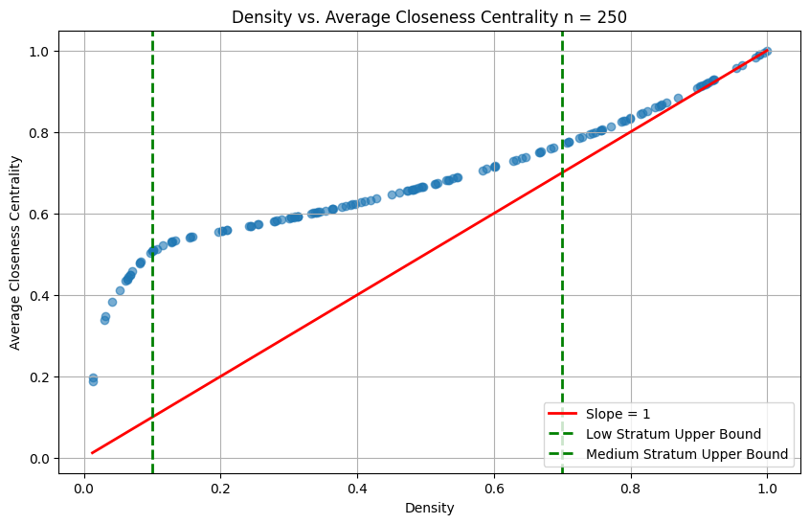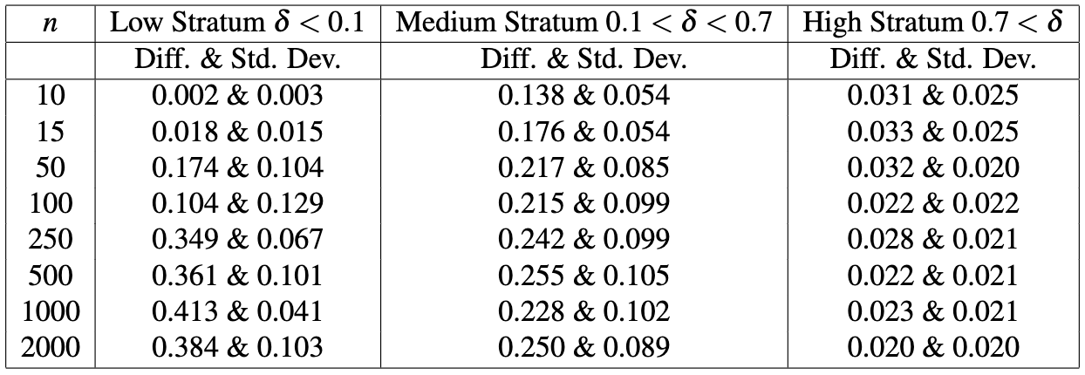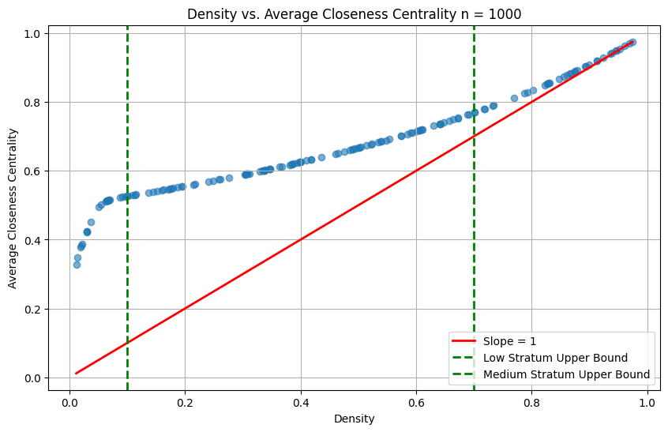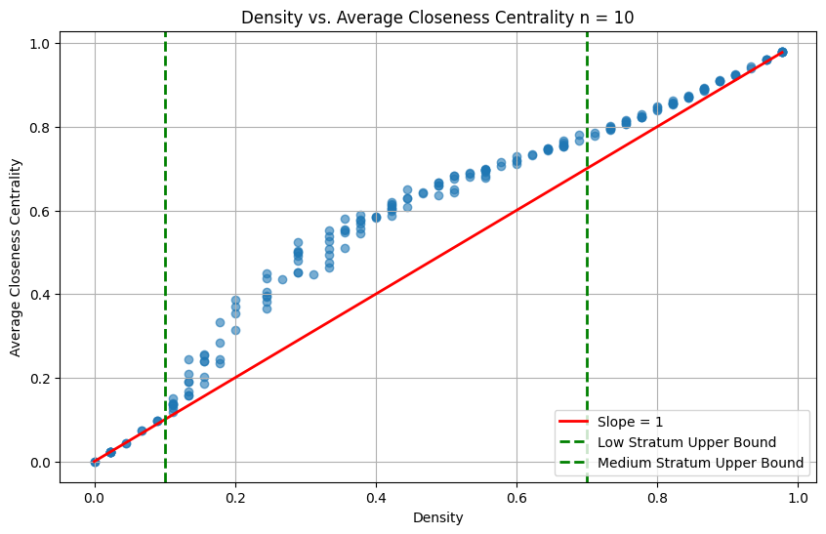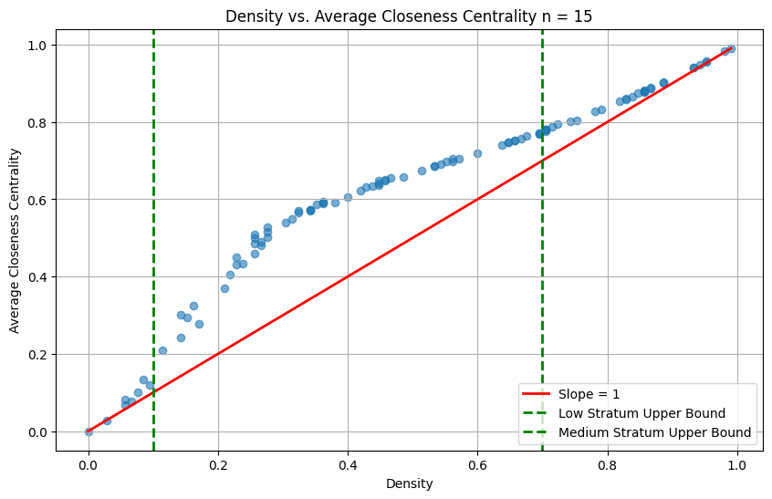

## Appendix D: *MH* *LCδmodifier* Values

The following is the distribution of all possible values of *LCδmodifier* based on *LCδh*. It begins at 0 and exponentially increases as *LCδh* approaches 0.2, after which it stays at 1, not modifying the *MH* score at all.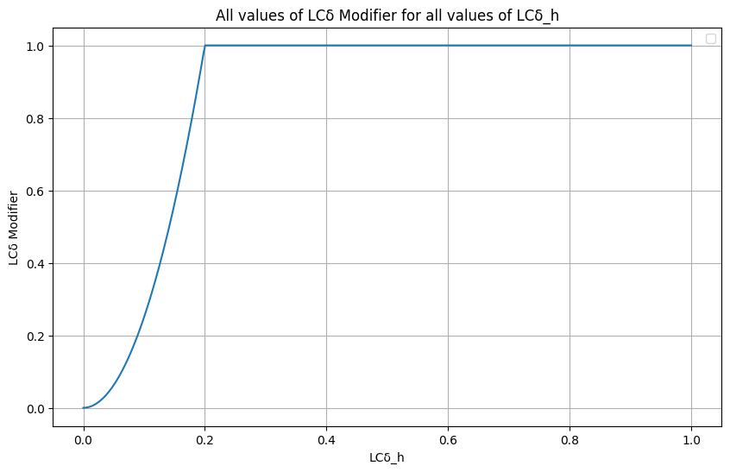

# References

[Alcalde, Baptiste, and Sjouke Mauw. “An Algebra for Trust Dilution and Trust Fusion.” In *Formal Aspects in Security and Trust*, edited by Pierpaolo Degano and Joshua D. Guttman, 5983:4–20. Lecture Notes in Computer Science. Berlin, Heidelberg: Springer Berlin Heidelberg, 2010.](https://www.zotero.org/google-docs/?BZ65xF) <https://doi.org/10.1007/978-3-642-12459-4_2>[.](https://www.zotero.org/google-docs/?BZ65xF)

[Ancona, Deborah G., ed. *Managing for the Future: Organizational Behavior & Processes*. 3rd ed. Mason, OH: Thomson/South-Western, 2005.](https://www.zotero.org/google-docs/?BZ65xF)

[Becerra, David, David K. Androff, Cecilia Ayón, and Jason T. Castillo. “Fear vs. Facts: Examining the Economic Impact of Undocumented Immigrants in the U.S.” *The Journal of Sociology & Social Welfare* 39, no. 4 (December 1, 2012).](https://www.zotero.org/google-docs/?BZ65xF) <https://doi.org/10.15453/0191-5096.3702>[.](https://www.zotero.org/google-docs/?BZ65xF)

[Benesty, Jacob, ed. *Noise Reduction in Speech Processing*. Springer Topics in Signal Processing, Vol. 2. Berlin Heidelberg: Springer, 2009.](https://www.zotero.org/google-docs/?BZ65xF)

[Blondel, Vincent D, Jean-Loup Guillaume, Renaud Lambiotte, and Etienne Lefebvre. “Fast Unfolding of Communities in Large Networks.” *Journal of Statistical Mechanics: Theory and Experiment* 2008, no. 10 (October 9, 2008): P10008.](https://www.zotero.org/google-docs/?BZ65xF) <https://doi.org/10.1088/1742-5468/2008/10/P10008>[.](https://www.zotero.org/google-docs/?BZ65xF)

[Bolton, Rendelle, Caroline Logan, and Jody Hoffer Gittell. “Revisiting Relational Coordination: A Systematic Review.” *The Journal of Applied Behavioral Science* 57, no. 3 (September 2021): 290–322.](https://www.zotero.org/google-docs/?BZ65xF) <https://doi.org/10.1177/0021886321991597>[.](https://www.zotero.org/google-docs/?BZ65xF)

[Carroll, John S. “3. Three Lenses for Understanding Reliable, Safe, and Effective Organizations: Strategic Design, Political, and Cultural Approaches.” In *Organizing for Reliability*, edited by Ranga Ramanujam and Karlene H. Roberts, 37–60. Stanford University Press, 2020.](https://www.zotero.org/google-docs/?BZ65xF) <https://doi.org/10.1515/9781503604537-004>[.](https://www.zotero.org/google-docs/?BZ65xF)

[Davis, Jason P. “The Group Dynamics of Interorganizational Relationships: Collaborating with Multiple Partners in Innovation Ecosystems.” *Administrative Science Quarterly* 61, no. 4 (December 2016): 621–61.](https://www.zotero.org/google-docs/?BZ65xF) <https://doi.org/10.1177/0001839216649350>[.](https://www.zotero.org/google-docs/?BZ65xF)

[Eveland, William P., and Steven B. Kleinman. “Comparing General and Political Discussion Networks Within Voluntary Organizations Using Social Network Analysis.” *Political Behavior* 35, no. 1 (March 2013): 65–87.](https://www.zotero.org/google-docs/?BZ65xF) <https://doi.org/10.1007/s11109-011-9187-4>[.](https://www.zotero.org/google-docs/?BZ65xF)

[Fernandez, Roberto M., and Doug McAdam. “Social Networks and Social Movements: Multiorganizational Fields and Recruitment to Mississippi Freedom Summer.” *Sociological Forum* 3, no. 3 (1988): 357–82.](https://www.zotero.org/google-docs/?BZ65xF) <https://doi.org/10.1007/BF01116431>[.](https://www.zotero.org/google-docs/?BZ65xF)

[Gittell, Jody Hoffer, and Hebatallah Naim Ali. *Relational Analytics: Guidelines for Analysis and Action*. New York, NY: Routledge, 2021.](https://www.zotero.org/google-docs/?BZ65xF)

[Newman, M. E. J. *Networks: An Introduction*. Oxford ; New York: Oxford University Press, 2010.](https://www.zotero.org/google-docs/?BZ65xF)

[Serva, Mark A., Mark A. Fuller, and Roger C. Mayer. “The Reciprocal Nature of Trust: A Longitudinal Study of Interacting Teams.” *Journal of Organizational Behavior* 26, no. 6 (September 2005): 625–48.](https://www.zotero.org/google-docs/?BZ65xF) <https://doi.org/10.1002/job.331>[.](https://www.zotero.org/google-docs/?BZ65xF)

[*Structural Holes*. Cambridge, MA: Harvard University Press, 2021.](https://www.zotero.org/google-docs/?BZ65xF)

1. [David Becerra et al., “Fear vs. Facts: Examining the Economic Impact of Undocumented Immigrants in the U.S.,” *The Journal of Sociology & Social Welfare* 39, no. 4 (December 1, 2012), https://doi.org/10.15453/0191-5096.3702.](https://www.zotero.org/google-docs/?FPBbLz)
2. [Deborah G. Ancona, ed., *Managing for the Future: Organizational Behavior & Processes*, 3rd ed (Mason, OH: Thomson/South-Western, 2005).](https://www.zotero.org/google-docs/?a1UkQI)
3. [Ancona.](https://www.zotero.org/google-docs/?l7BvBk)
4. [John S. Carroll, “3. Three Lenses for Understanding Reliable, Safe, and Effective Organizations: Strategic Design, Political, and Cultural Approaches,” in *Organizing for Reliability*, ed. Ranga Ramanujam and Karlene H. Roberts (Stanford University Press, 2020), 37–60, https://doi.org/10.1515/9781503604537-004.](https://www.zotero.org/google-docs/?X9TV2z)
5. [Rendelle Bolton, Caroline Logan, and Jody Hoffer Gittell, “Revisiting Relational Coordination: A Systematic Review,” *The Journal of Applied Behavioral Science* 57, no. 3 (September 2021): 290–322, https://doi.org/10.1177/0021886321991597.](https://www.zotero.org/google-docs/?Mcw33F)
6. [Jody Hoffer Gittell and Hebatallah Naim Ali, *Relational Analytics: Guidelines for Analysis and Action* (New York, NY: Routledge, 2021).](https://www.zotero.org/google-docs/?2lBsip)
7. [M. E. J. Newman, *Networks: An Introduction* (Oxford ; New York: Oxford University Press, 2010).](https://www.zotero.org/google-docs/?PK8eh7)
8. Other nodes that a node of interest is directly connected to
9. [Roberto M. Fernandez and Doug McAdam, “Social Networks and Social Movements: Multiorganizational Fields and Recruitment to Mississippi Freedom Summer,” *Sociological Forum* 3, no. 3 (1988): 357–82, https://doi.org/10.1007/BF01116431.](https://www.zotero.org/google-docs/?J6JG5U)
10. [William P. Eveland and Steven B. Kleinman, “Comparing General and Political Discussion Networks Within Voluntary Organizations Using Social Network Analysis,” *Political Behavior* 35, no. 1 (March 2013): 65–87, https://doi.org/10.1007/s11109-011-9187-4.](https://www.zotero.org/google-docs/?d9VKOF)
11. Except for the CFO, who did not come into the office at any point while I was present.
12. “Dreamer” is a term in US immigration used to refer to children who were brought into the country illegally and despite growing up in the US do not have legal status
13. Despite being the director of the entire organization, the executive director co-manages the advocacy team with the advocacy co-director, overseeing it far more closely than the legal or education team, which he leaves to the autonomy of his siblings.
14. This quote was translated from the original Spanish by the author
15. [Mark A. Serva, Mark A. Fuller, and Roger C. Mayer, “The Reciprocal Nature of Trust: A Longitudinal Study of Interacting Teams,” *Journal of Organizational Behavior* 26, no. 6 (September 2005): 625–48, https://doi.org/10.1002/job.331.](https://www.zotero.org/google-docs/?4CWtQR)
16. [Vincent D Blondel et al., “Fast Unfolding of Communities in Large Networks,” *Journal of Statistical Mechanics: Theory and Experiment* 2008, no. 10 (October 9, 2008): P10008, https://doi.org/10.1088/1742-5468/2008/10/P10008.](https://www.zotero.org/google-docs/?BhVIbq)
17. The legend for the network visualizations is as follows: XD = Executive Director, CFO = Chief Financial Officer, AD = Advocacy Director, LD = Legal Director, ED = Education Director, OM = Office Manager, R = Receptionist, NR = New Receptionist, A = Archivist, LI = Legal Intern, AI = Advocacy Intern, V = Volunteer
18. Luxburg, Ulrike von. 2007. “A Tutorial on Spectral Clustering.” *Statistics and Computing* 17 (4): 395–416. <https://doi.org/10.1007/s11222-007-9033-z>.
19. Edges with a weight of 3 are in dark violet and the widest, edges with a weight of 2 are light violet and the second widest, and edges with a weight of 1 are dark purple and the thinnest
20. Clauset, A, MEJ Newman, and C Moore. 2004. “Finding Community Structure in Very Large Networks.” *Physical Review. E* 70 (6). <https://doi.org/10.1103/PhysRevE.70.066111>.
21. Spectral clustering can be applied to directed graphs, however, the python function I used (sklearn.cluster.SpectralClustering) has difficulty with directed graphs since it relies on the symmetry of laplacian matrices in order to ensure all eigenvectors are real and non-negative and I did not want to treat the trust or help networks as undirected, which is the typical workaround.
22. [Serva, Fuller, and Mayer, “The Reciprocal Nature of Trust.”](https://www.zotero.org/google-docs/?rrKhRp)
23. The similarity heuristic is a tendency to trust others who are similar in appearance, beliefs, background, or behavior, due to a perceived shared identity or common ground. In DREAM’s case, this could either be due to shared identity as DREAM members, or potentially even because all the names on the survey were Hispanic names.
24. [Jacob Benesty, ed., *Noise Reduction in Speech Processing*, Springer Topics in Signal Processing, Vol. 2 (Berlin Heidelberg: Springer, 2009).](https://www.zotero.org/google-docs/?00ibaV)
25. Pearson’s R has a minimum value of -1 and a maximum value of 1. Both extremes represent a complete correlation in either a positive or negative direction. A value of 0 indicates no correlation between the two datasets
26. I chose to exclude these from the overall average for the reason I described earlier: that comparing directed and undirected degree vectors is not a great comparison. Including them resulted in an average Pearson’s R of 0.439
27. [Baptiste Alcalde and Sjouke Mauw, “An Algebra for Trust Dilution and Trust Fusion,” in *Formal Aspects in Security and Trust*, ed. Pierpaolo Degano and Joshua D. Guttman, vol. 5983, Lecture Notes in Computer Science (Berlin, Heidelberg: Springer Berlin Heidelberg, 2010), 4–20, https://doi.org/10.1007/978-3-642-12459-4_2.](https://www.zotero.org/google-docs/?hHhJjO)
28. [*Structural Holes* (Cambridge, MA: Harvard University Press, 2021).](https://www.zotero.org/google-docs/?Wv94EX)
29. [Jason P. Davis, “The Group Dynamics of Interorganizational Relationships: Collaborating with Multiple Partners in Innovation Ecosystems,” *Administrative Science Quarterly* 61, no. 4 (December 2016): 621–61, https://doi.org/10.1177/0001839216649350.](https://www.zotero.org/google-docs/?vYRexg)
30. [Bolton, Logan, and Gittell, “Revisiting Relational Coordination.”](https://www.zotero.org/google-docs/?fOr5FS)